

PROJECT REPORT

**ON**

**CRAFT VERSE**

SUBMITTED

TO

**ROURKELA INSTITUTE OF MANAGEMENT STUDIES**

(As a partial fulfilment of the requirement for the award of Degree)

**FOR**

**MASTER IN COMPUTER APPLICATION**

**SUBMITED BY**

**RAJALAXMI MAJHI**

REGD NO: 2305260018

**MCA 4TH SEMESTER (2023-2025)**

ROURKELA INSTITUTE OF MANAGEMENT STUDIES

(Affiliated to Biju Patnaik University of Technology)

**1**



**Rourkela Institute of Management Studies**

Rourkela

Department of Computer Science Rourkela Institute of Management Studies Chhend, Rourkela-15, Odisha Phone:0661 2480482

Fax: 91-0661-1480665

Mail: [rkl_rimsgrol@sancharnet.in](mailto:rkl_rimsgrol@sancharnet.in)Visit:

[www.rims-edu.com](http://www.rims-edu.com/)

**CERTIFICATE OF EXAMINATON**

This is to certify that this project report entitled **“CRAFT VERSE”** submitted by **RAJALAXMI MAJHI** of 4th semester, **Rourkela Institute of Management Studies, Rourkela,** is accepted as partial fulfillment of requirements for the degree in Master in Computer Applications, under **Biju Patnaik University of Technology, Rourkela** this has been verified by us and found be original up to our satisfaction.

Examiner

**2**



**Rourkela Institute of Management Studies**

Rourkela

Department of Computer Science Rourkela Institute of Management Studies, Chhend, Rourkela-15, Odisha

Phone:0661 2480482 Fax:91-0661-1480665

Mail: [rkl_rimsgrol@sancharnet.in](mailto:rkl_rimsgrol@sancharnet.in)Visit:

[www.rims-edu.com](http://www.rims-edu.com/)

CERTIFICATE OF EXAMINATON

This is to certify that this project report entitled **“CRAFT VERSE”** submitted by **RAJALAXMI MAJHI** of 4th semester, **Rourkela Institute of Management Studies, Rourkela,** is accepted as partial fulfilment of requirements for the degree in Master in Computer Applications, under **Biju Patnaik University of Technology, Rourkela** this has been verified by us and found be original up to our satisfaction.

Examiner

**3**



**Rourkela Institute of Management Studies**

Rourkela

Department of Computer Science Rourkela Institute of Management Studies Chhend, Rourkela-15, Odisha Phone:0661 2480482

Fax:91-0661-1480665

Mail: [rkl_rimsgrol@sancharnet.in](mailto:rkl_rimsgrol@sancharnet.in) Visit: [www.rims-edu.com](http://www.rims-edu.com/)

CERTIFICATE

This is to certify that this project entitled **“CRAFT VERSE”** has been and submitted by **RAJALAXMI MAJHI,** M.C.A 2023-2025, **Rourkela Institute of Management Studies, Rourkela,** has been examined by us.

She is found fit and approved for the award of **“Master in Computer Application “**Degree.

To the best my knowledge this work has not been submitted for the award of any other degree.

DEAN ACADEMICRIMS, ROURKELA

**4**



Prof. Bibhudendu Panda Head of The Department, MCA

Rourkela Institute of Management Studies Rourkela

CERTIFICATE

This is to certify that **RAJALAXMI MAJHI** student of **M.C.A, Rourkela Institute of Management Studies, Rourkela, Odisha** ofSession 2023-2025 has completed the project successfully.

**(Prof. Bibhudendu Panda)**

**5**



DECLARATION

I, **RAJALAXMI MAJHI**, hereby declare that the project report entitled “**CRAFT VERSE**” is of my work. The above work I submitted to “**Biju PatnaikUniversity of Technology, Rourkela”** for the award of **“Master in Computer Applications**” Degree.

To the best of my knowledge, this work has not been submitted or published anywhere for the award of any degree.

RAJALAXMI MAJHI

**6**



ACKNOWLGEMENT

I would like to express my heartfelt gratitude to **Mr. Rashmi Kanta Das** (Java Technocrat) and **Mr. Smruti Ranjan Nayak** for their invaluable guidance and

support throughout my project work. Their insights and encouragement have

been instrumental in shaping this project.

I am deeply grateful to Rourkela Institute of Management Studies (RIMS),

Chhend, Rourkela, for providing me with the opportunity to undertake this

project, "CRAFT VERSE." The learning experience has been truly enriching.

A special thanks to my project guide**, Prof.** **Bibhudendu Panda**, whose constant support, constructive feedback, and expert guidance made it possible for me to complete this project successfully.

I also extend my appreciation to my team members for their cooperation, dedication, and collaborative efforts in making this project a success.

Lastly, I consider myself fortunate to have successfully completed this project,

and I sincerely acknowledge the contributions of everyone whose ideas and

efforts have helped me throughout this journey.

*RAJALAXMI MAJHI*

**University Roll No:** 2305260018 **MCA (2023-2025)**

**Rourkela Institute of Management Studies, Rourkela.**

**7**

ABSTRACT

**Craft Verse** is an e-commerce platform designed to provide a seamless shopping experience for craft enthusiasts, offering a wide range of handcrafted products. The website is developed using **Spring Boot**, ensuring a robust, scalable, and efficient backend for managing products, user interactions, and secure transactions.

The primary objective of **Craft Verse** is to connect artisans with buyers by providing a digital marketplace for unique and artistic craft items such as paintings, sculptures, resin art, and DIY kits. The platform is designed with a **responsive UI**, enabling smooth navigation, product browsing, and an easy checkout process. Key features include **user authentication, order tracking, wishlist management, and a secure payment gateway**.

By leveraging **Spring Boot**, the project ensures high performance, security, and maintainability. The backend architecture efficiently handles product management, user data, and order processing while integrating with a relational database for seamless data storage and retrieval.

Through **Craft Verse**, we aim to promote handmade crafts, support artisans, and enhance the online shopping experience by delivering a well-structured, scalable, and user-friendly platform.

**8**

**CONTRIBUTION OF INDIVIDUAL TEAM MEMBERS**

|  |  |  |
| --- | --- | --- |
| **Name of the Student(s)** | **Registration Number** | **Contributions** |
| Madhusmita Sahoo | 2305260011 | Frontend, Database & Backend |
| Rajalaxmi Majhi | 2305260018 | Frontend, Database & Security |

**9**

GANTT CHART

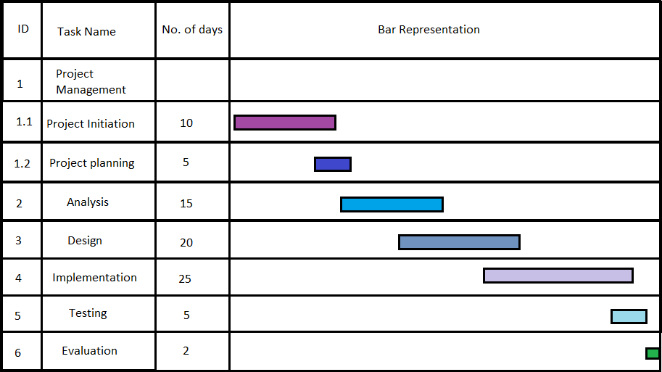

**10**

**Table of Contents**

|  |  |  |
| --- | --- | --- |
| **Sl.No.** | **Title** | **Page No.** |
| 1 | FRONT PAGE | 01 |
| 2 | CERTIFICATION OF EXAINATION | 02 |
| 3 | CERTIFICATE | 03 |
| 4 | DECLARATION | 04 |
| 5 | ACKNOWLGEMENT | 05 |
| 6 | ABSTACT | 06 |
| 7 | TEAM MEMBER CONTRIBUTION | 07 |
| 8 | GANTT CHART | 08 |
| 9 | INTRODUCTION | 12-16 |
| 10 | LITERETURE SURVEY | 17-19 |
| 11 | PROJECT PLANNING | 20-22 |
| 12 | ENVIRONMENT SETTINGS | 23-43 |
| 13 | SELECTED SOFTWARE PLATFROM | 44-50 |
| 14 | SELECTED DEVELOPMENT LIFE CYCLE | 50-52 |
| 15 | METHODOLOGY | 53-59 |
| 16 | CODING | 60-62 |
| 17 | SNAPSHOT | 63-76 |
| 18 | TESTING | 77-79 |
| 19 | CONCLUSION AND FUTURE SCOPE | 80-81 |
| 20 | REFERENCES | 82 |

**11**

# CHAPTER-1

###### INTRODUCTION

* 1. **Preface**
     + **Craft Verse** is an e-commerce platform dedicated to selling handcrafted products, providing a seamless shopping experience for craft enthusiasts.
     + The platform connects skilled artisans with customers by offering a diverse range of handmade goods, including paintings, sculptures, resin art, DIY kits, and other unique craft items. The website is built using **Spring Boot and Java**, ensuring a scalable, secure, and high-performance system for managing products, user interactions, and transactions.
  2. **Understanding the Problem Statement**

Before diving into the implementation, it is essential to define the core problem we aim to solve. Traditional marketplaces often lack a dedicated space where artisans can **showcase and sell their handcrafted items effectively**. Many existing platforms either focus on mass-produced goods or fail to provide a tailored experience for craft lovers.

To address this, **Craft Verse** is designed to:

* **Provide an online marketplace** where artisans can list and sell their handmade crafts.
* **Ensure a user-friendly shopping experience** with seamless navigation, product browsing, and a secure checkout process. **Offer backend efficiency** with robust inventory management, order processing, and payment integration using **Spring Boot and Java**

**12**

* 1. **Motivation for Work**

The demand for **handmade and artistic products** is increasing, but independent artisans

often struggle to reach a wider audience due to the lack of an efficient digital marketplace.

**Craft**  **Verse** is built to bridge this gap by providing:

* A **platform where artisans can showcase their creativity** without facing logistical and marketing challenges.
* A **secure and scalable e-commerce solution** using modern web technologies.
* A system that allows **smooth order management, customer engagement, and transaction handling**.
* By leveraging **Spring Boot** for backend development, **Craft Verse** ensures a **structured, high-performance, and reliable** e-commerce platform for craft lovers.

**Project Overview**

**Craft Verse** is a fully functional e-commerce platform that facilitates the buying and selling of handcrafted products. The platform provides:

* **Product Listings**: Artisans can upload product images, descriptions, and prices.
* **User Authentication**: Secure login and registration for buyers and sellers.
* **Shopping Cart & Wishlist**: Users can save and manage their favorate products.
* **Order Management**: Efficient tracking of orders from placement to delivery.
* **Responsive UI**: A visually appealing and easy-to-navigate interface for users.

The platform ensures smooth backend operations using **Spring Boot**, which handles **product inventory, user authentication, and order processing** seamlessly.

**14**

**1.4 Purpose**

The The primary goal of **Craft Verse** is to create an **efficient, scalable, and secure online marketplace** dedicated to handcrafted products. The website:

* Provides a **dedicated space** for artisans to sell their unique craft items.
* Ensures **a seamless user experience** with smooth navigation and secure transactions.
* Supports **a structured backend system** using **Spring Boot and Java** for efficient management of products, orders, and users.

With the growing demand for unique handmade products, **Craft Verse** serves as a **digital bridge** between artisans and customers, making handcrafted goods more accessible.

**1.5 Project Scope**

The project is designed to **simplify online craft shopping and selling** by offering:

* **A structured product catalog** for efficient browsing.
* **A secure and scalable backend** to handle user data, product listings, and orders.
* **A responsive and intuitive UI** for enhanced user experience.
* **Secure payment gateways** to ensure smooth transactions.

By using **Spring Boot and Java**, the project ensures a **reliable and maintainable** architecture, making it easy to scale as demand grows.

**15**

* 1. **Project Goals and Objectives**

**1.6.1Goals**

* To develop a **dedicated online marketplace** for handcrafted products.
* To implement **a secure and scalable e-commerce system** using **Spring Boot and Java**.
* To enhance **user experience and backend efficiency** for seamless transactions.

**Objectives**

* **E-commerce Platform:** Provide a well-structured online marketplace for artisans and craft lovers.
* **User-Friendly Interface:** Design an intuitive UI for easy navigation and shopping.
* **Efficient Backend Management:** Develop a robust backend to handle product listings, orders, and transactions.
* **Scalability and Security:** Ensure a secure and scalable platform using Spring Boot and Java.
  1. **Requirements Specifications**
     1. **Hardware Specifications**
     + RAM- 4 Gb or Higher
     + HDD- 1TB
     + SSD- 120Gb
     + Processor- i5
     1. **Software Specifications**

Windows- win-10, win-11

Frontend Language- HTML, CSS, JavaScript

Backend Language- Java

Database: MySQL

Framework: SpringBoot Framework

Vision Controller: Github

**16**

# CHAPTER-2

LITERETURE SURVEY

The main objective of this study is to develop an **efficient and scalable e-commerce platform** for selling handcrafted products. While analyzing various web development frameworks and technologies, we found that platforms like **WordPress and Shopify** have limitations when it comes to customization and scalability for niche marketplaces. In this paper, we present and review a more **feasible approach using Spring Boot and Java** to build a robust, secure, and feature-rich **craft-selling platform**.

The first step in our development process was to design a **structured database** for storing product details, user information, and transactions. The database was optimized for efficient data retrieval and management.

Our study also focuses on implementing **backend logic with Spring Boot**, ensuring seamless order processing, product management, and user authentication. Additionally, we have incorporated **secure payment gateways and responsive UI designs** to enhance the overall user experience.

**2.1.1 Advantages of Paper**

a) **Customizable and Scalable Platform** – Unlike third-party e-commerce solutions, our system

provides full customization and scalability tailored for the craft industry.

c) **Secure Transactions and User Authentication** – The platform integrates **secure payment**

**gateways and authentication mechanisms** to ensure data privacy and safe transactions.

* + 1. **Disadvantages of Paper**

**a) Limited Customization –** Many existing platforms do not offer customized features

for niche markets like handcrafted goods**.  
b) High Transaction Fees** – Third-party e-commerce services charge high commission fees, reducing artisans' profits.  
**c) Scalability Issues –** Some platforms are not optimized for performance, causing delays in high-traffic scenarios.

**17**

**2.1.3How to overcome the problems mentioned in Paper**

1. **Spring Boot for Backend Development** – Our platform uses **Spring Boot**, providing a structured and high-performance backend.
2. **Optimized Database Management** – We use **MySQL** to handle large datasets efficiently while ensuring fast query responses.
3. **Secure Payment Gateway Integration** – The platform integrates **multiple payment options** for seamless transactions.
   1. Technical Review

Modern e-commerce platforms rely on **highly optimized backend frameworks** to ensure smooth transactions, secure user data, and efficient product management. **Spring Boot** is a powerful framework for building large-scale applications, making it an ideal choice for **Craft Verse**.

Our study focuses on:

* + **Developing a secure and scalable backend using Spring Boot and Java**.
  + **Implementing an optimized relational database (MySQL) for product, order, and user data**

**storage**.

* + **Enhancing frontend responsiveness** using **HTML, CSS, JavaScript, and Angular**.
  + **Integrating secure payment systems** for fraud prevention and transaction security.

By leveraging **Spring Boot’s REST API capabilities**, we ensure seamless communication between the frontend and backend, improving **data flow, scalability, and performance**.

2.4.1 Advantages of Using Spring Boot & Java for E-commerce

a) High Performance & Scalability – Spring Boot provides a lightweight and efficient framework for handling large datasets and multiple transactions.  
b) Secure Transactions & Authentication – Java’s security features allow for strong user authentication, data encryption, and fraud prevention.  
c) Seamless API Integration – RESTful APIs enable smooth integration with third-party payment gateways and analytics tools.

2.4.2 Reasons for Choosing Spring Boot & Java

a) Custom E-commerce Development – Unlike pre-built solutions, Spring Boot allows full customization, making it ideal for niche marketplaces like Craft Verse.

b) Robust Backend System – Ensures secure user management, order tracking, and

payment processing.

c) Future Scalability – The platform is built to handle increasing traffic and product listings

as the business grows.

**19**

# CHAPTER-3

### PROJECT PLANNING

**Craft Verse** is an e-commerce platform designed to connect artisans and craft vendors with customers seeking handmade and

artistic products. The project follows a structured **Software Development Life Cycle (SDLC)** approach, ensuring **efficient**

**development, scalability, and seamless user experience**.

This document outlines the **project planning process**, covering scope, objectives, milestones, resource allocation, risk management, and expected deliverables.

**2. Project Scope**

**2.1 Objectives**

Develop a **user-friendly** and **secure** craft marketplace for artisans and buyers.  
 Implement a **robust backend** using **Spring Boot & MySQL** for efficient data management.  
 Ensure a **responsive and interactive UI** using **React.js & Bootstrap**.  
 Integrate **secure payment gateways** (Stripe, PayPal) for smooth transactions.  
 Provide **vendor dashboards** for inventory and sales tracking.  
 Implement **real-time order tracking and customer support**.

**2.2 Features**

**User Authentication & Role Management** (Customer, Vendor, Admin).  
 **Product Listing & Search Functionality** (Categories, Filters, Recommendations).  
 **Shopping Cart & Checkout System** with multiple payment options.  
 **Order Management** (Processing, Tracking, Delivery Updates).  
 **Vendor Management Portal** (Product Uploads, Sales Reports, Earnings).  
 **Customer Reviews & Ratings System**.

**3. Project Timeline & Milestones**

The project follows an **Agile development approach** with iterative releases.

| **Phase** | **Tasks** | **Duration** |
| --- | --- | --- |
| Requirement Gathering | Identify project goals, user needs, and technology stack. | Week 1–2 |
| System Design | Create UI wireframes, database schema, and system architecture. | Week 3–4 |
| Backend Development | Develop REST APIs using Spring Boot, database setup (MySQL). | Week 5–7 |
| Frontend Development | Implement UI using React.js and integrate APIs. | Week 8–10 |
| Testing & Bug Fixing | Conduct unit, integration, and performance testing. | Week 11–14 |
| Deployment & Launch | Host platform on AWS/GCP and finalize user testing. | Week 15 |

**4. Resource Allocation & Team Responsibilities**

| **Team Member** | **Role** | **Responsibilities** |
| --- | --- | --- |
| **Frontend Developer** | UI/UX Development | Design responsive UI using React.js, Bootstrap, and HTML/CSS. |
| **Backend Developer** | API Development | Implement business logic using Spring Boot and REST  APIs. |
| **Database Engineer** | Data Management | Manage database schemas and optimize queries in MySQL. |
| **QA Engineer** | Testing & Debugging | Perform unit testing, integration testing, and bug  tracking. |
| **Project Manager** | Planning & Coordination | Oversee progress, manage risks, and ensure timely delivery |

**20**

* 1. **Project Management Approach**

**Project Planning & Scope Definition**

* + - Identify key functionalities (e.g., product management, order tracking).
    - Establish project milestones and deliverables.

**Sprint-Based Development**

* Divide the project into **weekly development sprints** with clear goals.
* Conduct regular **code reviews and feature testing**.

**Time & Resource Management**

* Allocate appropriate time for **design, development, and testing**.
* Track progress using **Gantt charts and sprint reports**.

**Task Assignment & Collaboration**

* Assign specific tasks to team members based on expertise.
* Utilize **GitHub for version control** and real-time collaboration.

**Progress Reporting & Continuous Testing**

* + - Weekly check-ins with **project guides and mentors** to assess progress.
    - Perform **unit testing, integration testing, and security testing** before deployment.
  1. **Ground Rules for the Project**
     1. Properly planning and gathering relevant information is very important.
     2. Developing a Blueprint of the project and work accordingly.
     3. All the members should report to the guide whenever required
     4. Setting up small goals every week.
     5. Achieving the small goal within that span of time.
     6. Keeping tracks of the progress towards project.

**3.3Project Budget**

* + **Comprehensive Planning & Research** – Every aspect of the project must be well-documented

before execution.

* + **Blueprint & Wireframe Development** – UI/UX and system architecture must be finalized before

development begins.

**7**

**Regular Team Check-ins** – Weekly stand-up meetings to discuss progress, roadblocks, and upcoming tasks.  
 **Task Deadlines & Sprint Goals** – Each task must be completed within the assigned sprint cycle.  
 **Issue Tracking & Documentation** – All changes, bugs, and updates must be **logged on GitHub**.  
 **Security & Data Protection** – Ensure that user data, transactions, and authentication systems are secured.

**22**

# CHAPTER-4

ENVIRONMENT SETTINGS

###### Prerequisite

* JAVA 17 or above
* HTML, CSS, JS
* Microsoft Visual Studio Code
* Git Bash and GitHub
* Spring Boot Dependencies:

 Thyme-Leaf

2. Spring Web

3. Spring Boot Dev tools

4. MySQL Driver

5.Spring data JPA

6. Validation I/O

7. Lombok Developer Tools

8.Spring Security

**23**

**How to Install Visual Studio Code on Windows?**

Firstly, download the Visual Studio Code installer for Windows. Once it is downloaded, run the installer (*VSCodeUserSetup-{version}.exe*). It will only take a minute.

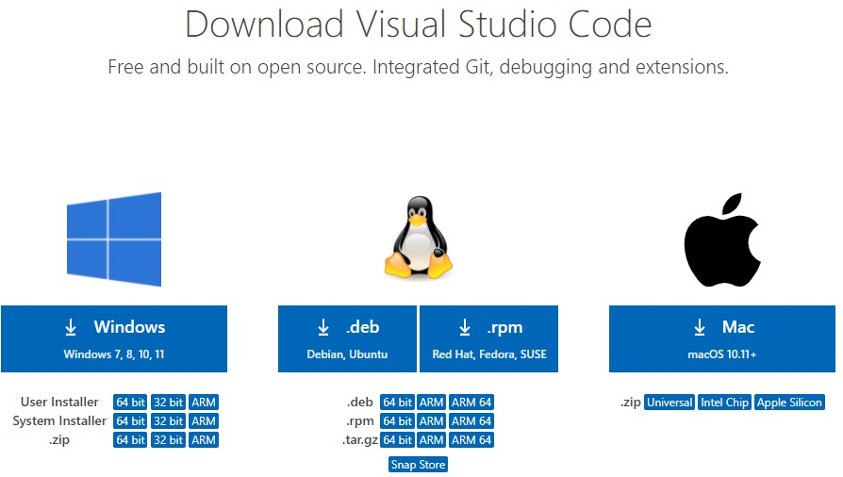

Then double Click on Download folder .exe file and Follow the step by step instruction Process .

Secondly, accept the agreement and click on next.

**24**

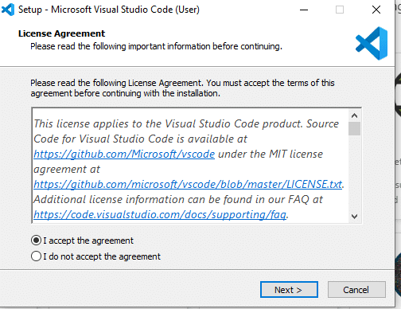

Thirdly, click on “**create a desktop icon**” so that it can be accessed from desktop and click on Next.

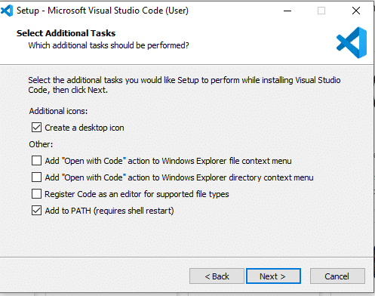

After that, click on the install button.

**25**

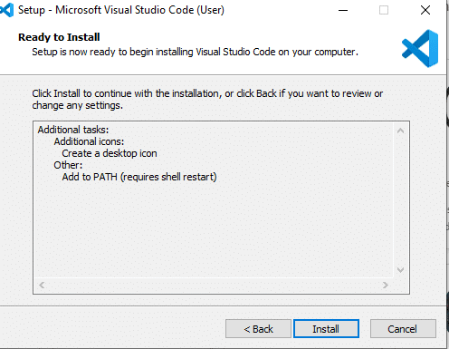

Finally, after installation completes, click on the finish button, and the visual studio code will get open.

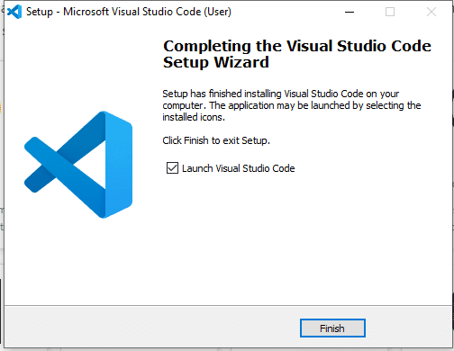

**26**

Steps to Install SPRING BOOT

Follow the steps below to easily install Spring on Windows.

**Step 1: Install Java Development Kit (JDK)**

Spring Boot requires **JDK 17 or later**.

**1. Download JDK**

* Go to [Oracle JDK Download](https://www.oracle.com/java/technologies/javase/jdk17-archive-downloads.html) .
* Download the **Windows x64 Installer**.

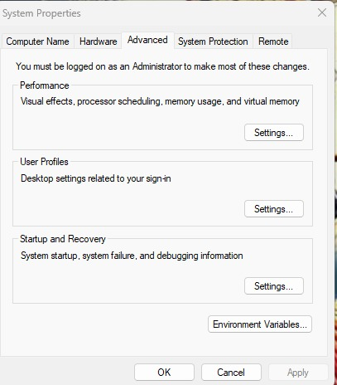

* 1. Run the downloaded .exe file and follow the installation instructions.

**3.Set up Environment Variables**

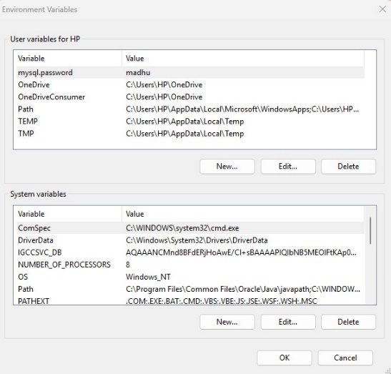

**27**

* Open **Windows Search**, type Environment Variables, and open **Edit the system environment variables**.
* Under **System Properties**, click **Environment Variables**.
* In **System Variables**, find **Path**, click **Edit**, and add the JDK bin path:
* C:\Program Files\Java\jdk-17\bin
* Add a new variable:
  + **Variable name:** JAVA_HOME
  + **Variable value:** C:\Program Files\Java\jdk-17

#### **Verify Installation**

#### 

Open **Command Prompt (cmd)** and type:

java -version

javac -version

**Step 2: Install Maven (Optional, but Recommended)**

Maven helps in managing Spring Boot dependencies.

**1. Download Apache Maven**

* Go to [Maven Download Page](https://maven.apache.org/download.cgi).
* Download **Binary zip archive**.

**2. Install and Configure Maven**

* Extract the ZIP file to a location (e.g., C:\apache-maven-3.9.5).
* Set up Environment Variables:
  + Add C:\apache-maven-3.9.5\bin to the **Path** variable.
  + Create a new system variable:
    - **Variable name:** MAVEN_HOME
    - **Variable value:** C:\apache-maven-3.9.5

**3. Verify Installation**

Open **Command Prompt** and type:

**28**

mvn -version

**Step 3: Install Spring Boot CLI (Optional)**

If you want to use **Spring Boot CLI** for rapid development, follow these steps:

**1. Download Spring Boot CLI**

* Go to [Spring Boot CLI Download](https://repo.spring.io/release/org/springframework/boot/spring-boot-cli/)
* Download the latest **spring-boot-cli-x.x.x-bin.zip** file.

**2. Install and Configure**

* Extract it to C:\spring-boot-cli.
* Add C:\spring-boot-cli\bin to the **Path** variable.

**3. Verify Installation**

Open **Command Prompt** and type:

**Step 4: Install an IDE (Eclipse/IntelliJ IDEA/VS Code)**

**1. Install Eclipse (STS)**

* Download **Spring Tool Suite (STS)** from [Spring Tools 4](https://spring.io/tools).
* Install it and open the IDE.

**2. Install IntelliJ IDEA**

* Download **IntelliJ IDEA Community Edition** from [JetBrains](https://www.jetbrains.com/idea/download/).
* Install and set up the **Spring Boot plugin**.

**Step 5: Create a Spring Boot Project**

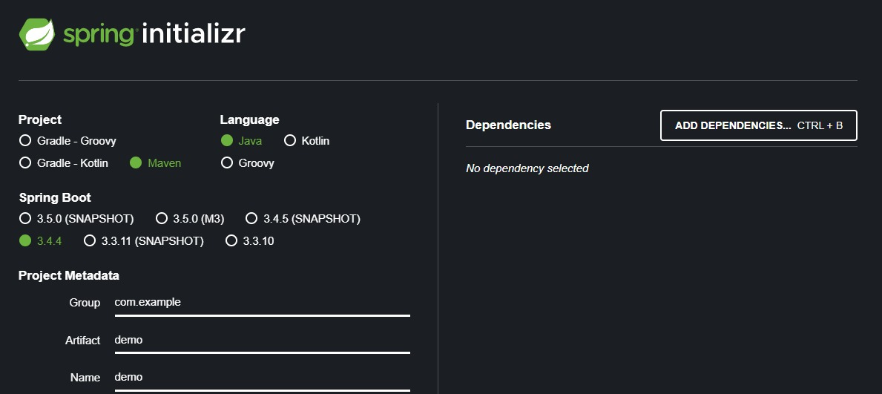

**1. Use Spring Initializer (Recommended)**

* Go to [Spring Initializer](https://start.spring.io/)
* Select:
  + **Project:** Maven
  + **Language:** Java
  + **Spring Boot Version:** Latest Stable
  + **Dependencies:** Spring Web, Spring Boot DevTools, Lombok, etc.
* Click **Generate** to download a pre-configured Spring Boot project.

**2. Open in IDE**

* Extract the ZIP file.
* Open it in Eclipse, IntelliJ, or VS Code.
* Run the main class:

**Step 6: Test Your Spring Boot App**

* Open a browser and go to: http://localhost:1211

Download and Install MySQL for Windows Steps

Step 1: Visit the Official MySQL Website

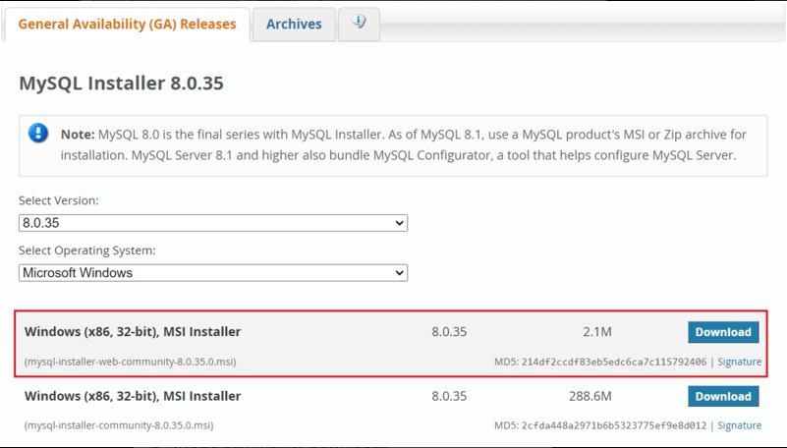

Open web browser and navigate to the official MySQL website. Now, Simple click on first download button.

Step 2: Go to the Downloads Section

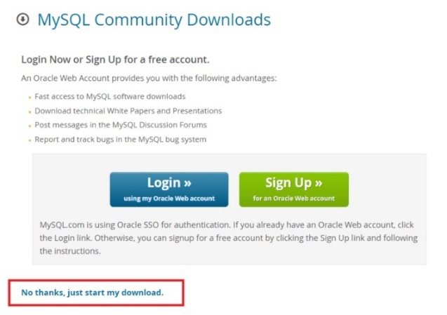

On the MySQL homepage, Click on the “ No thanks, just start my download” link to proceed MySql downloading.

Step 3: Run the Installer

After MySQL downloading MySQL.exe file, go to your Downloads folder, find the file, and double-click to

run the installer.

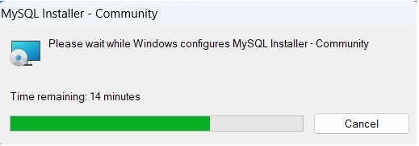

Step 4: Choose Setup Type

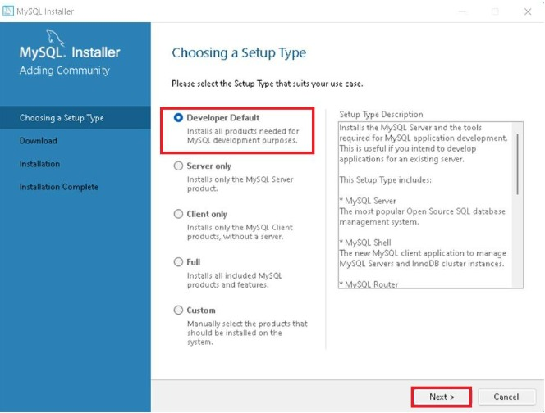

The installer will instruct you to choose the setup type. For most users, the “Developer Default” is suitable.

Click “Next” to proceed.

Step 5: Check Requirements

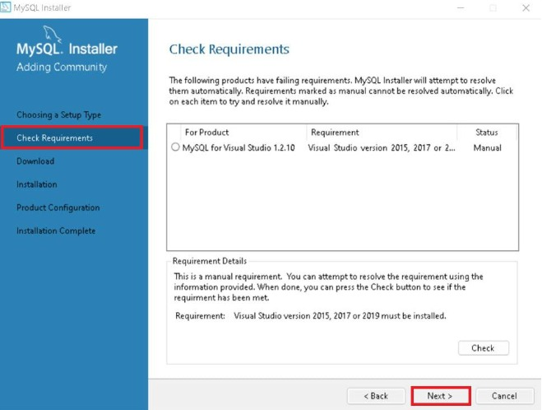

You might be prompted to install necessary MySQL software, typically Visual Code. The installer can auto-resolve

some issues, but not in this case.

Step 6: MySQL Downloading

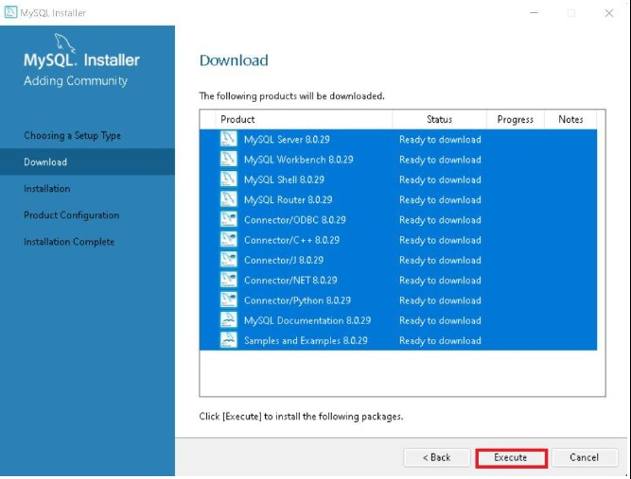

Now that you’re in the download section, click “Execute” to start downloading the components you selected.

Wait a few minutes until all items show tick marks, indicating completion, before moving forward.

Step 7: MySQL Installation

Now the downloaded components will be installed. Click “Execute” to start the installation process. MySQL will

be installed on your Windows system. Then click Next to proceed.

Step 8: Navigate to Few Configuration Pages

Proceed to “Product Configuration” > “Type and Networking” > “Authentication Method” Pages by clicking the “Next” button.

Step 9: Create MySQL Accounts

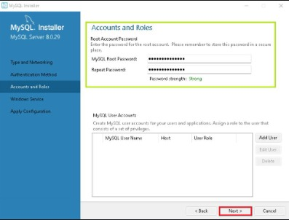

Create a password for the MySQL root user. Ensure it’s strong and memorable. Click “Next” to proceed.

Step 10: Connect To Server

**32**

Enter the root password, click Check. If it says “Connection succeed,” you’ve successfully connected to the server.

Step 11: Complete Installation

Once the installation is complete, click “Finish.” Congratulations! MySQL is now installed on your Windows system.

Step 12: Verify Installation

To ensure a successful installation of MySQL, open the MySQL Command Line Client or MySQL Workbench,

both available in your Start Menu. Log in using the root user credentials you set during installation.

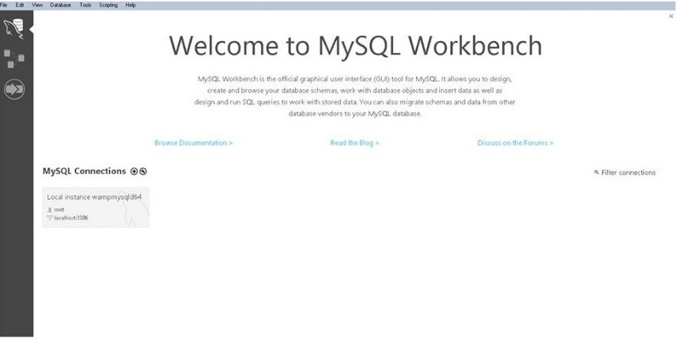

**How to Download and Setup GITBASH**

Step 1: Visit the Official Git Bash

Download the latest version of Git Bash from their official website: <https://git-scm.com/>

Click the “Download for windows” button.

Step 2: Start Git Bash Download

Next, you will be redirected to a page that lets you know that you are about to start download

Click the “Download for windows” button. Step 2: Start Git Bash Download

Next, you will be redirected to a page that lets you know that you are about to start downloading.

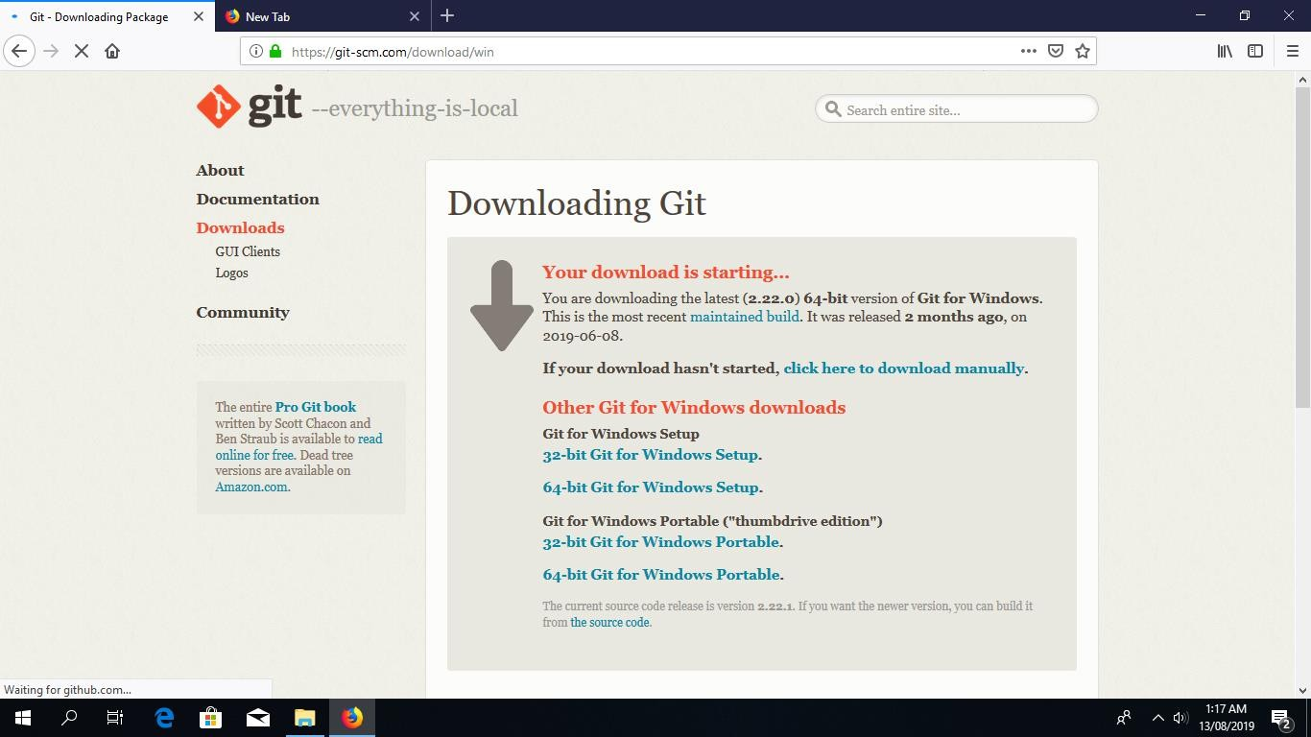

If all goes well, the download should start automatically.

**Tip:** If the download doesn’t start, click on the “click here to download manually” link.

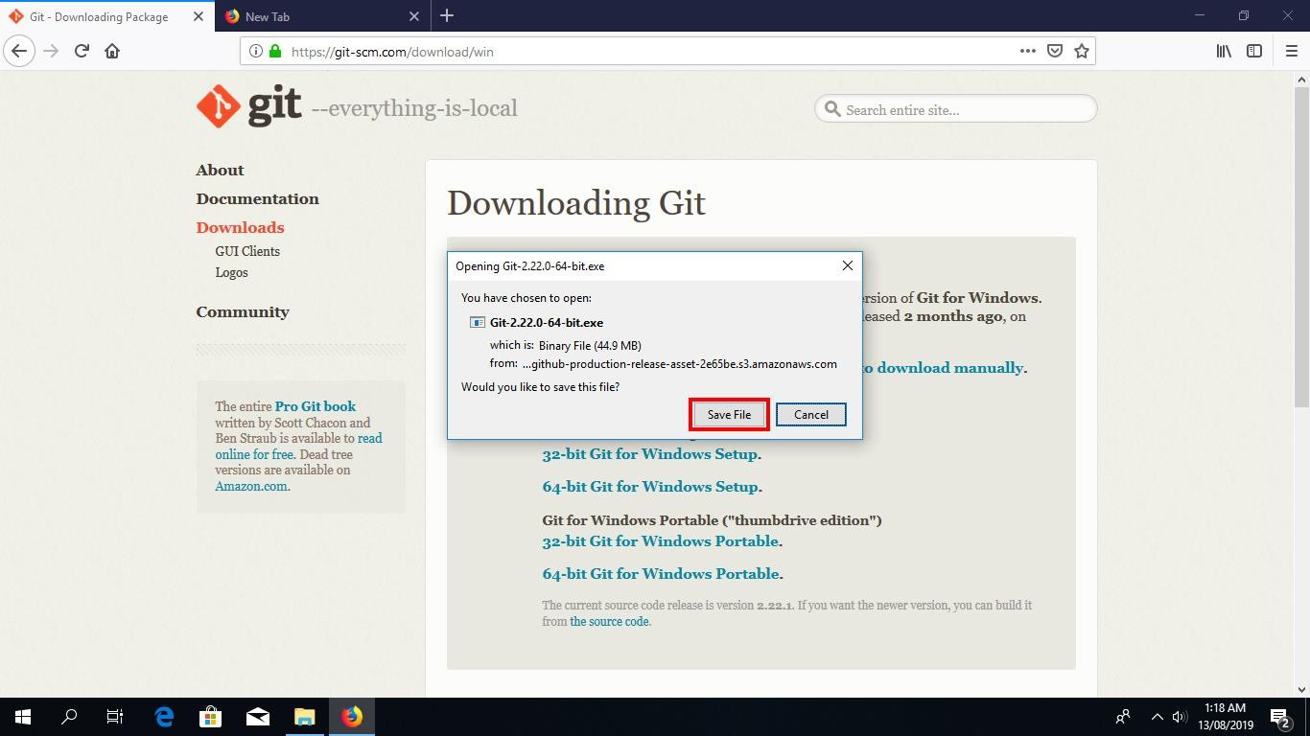

Click on “Save File” to start downloading the executable.

**Install Git Bash**

Step 3: Run the Installer

Once you have downloaded the Git Bash executable, click it to run the installer.

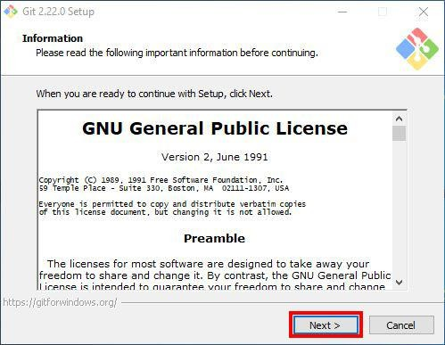

Click “Next” after you have read the license.

Step 4: Select Destination Location Permalink

Next, select the location you want to install Git Bash. I would recommend you just leave the default option as it is, and click “Next”.

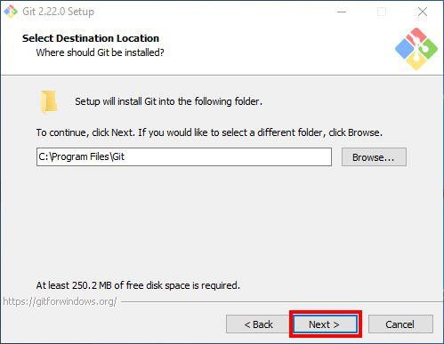

Step 5: Select Components

Choose the components you want to install, or you can just proceed with the default options and click “Next”. I prefer selecting the “Additional icons” component which creates a Git Bash shortcut on the desktop.

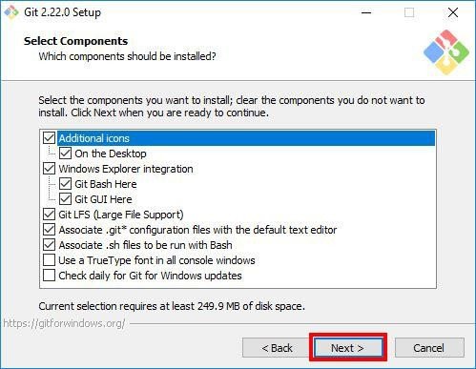

**36**

Step 6: Select Start Menu Folder

You can change the name of start menu folder here if you want, or just leave the default name and click “Next”.

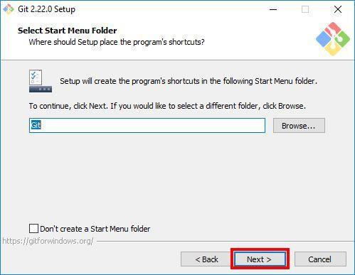

Step 7: Choose the Default Editor used by Git

Next, select the default editor for Git to use. Choose the one you like and click “Next”. I would recommend you proceed with **Nano** or **Notepad++**. Don’t proceed with the default option “Vim” as it has a steep learning curve.

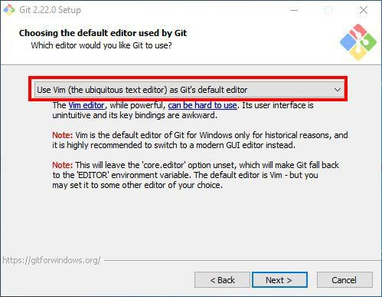

**37**

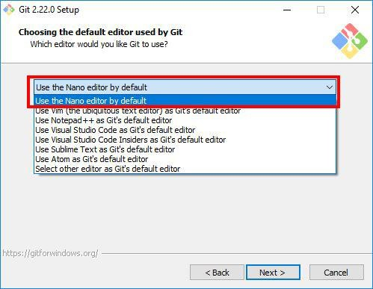

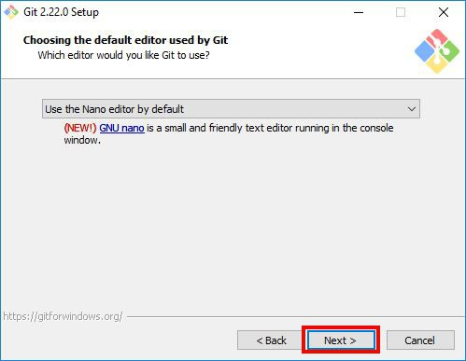

Step 8: Adjust your PATH Environment

Choose the option you want depending on where you want to use Git and click “Next”.

Select **“Use Git from Git Bash only”** option if want to run Git and Bash commands from Git Bash only. This means that you won’t be able to run Git commands such as git status on Windows Command Prompt or Powershell. They will only be found on Git Bash.

Select **“Git from the command line and also from 3rd-party software”** option if you want to

run Git commands on Windows Command Prompt or Powershell.

**38**

**Notice:** Bash commands won’t work on Command Prompt or Powershell with this option, but only Git commands will work.

**Tip:** If you need run bash commands, you will have to open the Git Bash. So go ahead with this option if that is what you want.

Select **“Use Git and optional Unix tools from the Command Prompt”** option if you want to use both Git and Bash commands on Windows Command Prompt or Powershell. This option will override some default Windows Command Prompt tools like find and sort. I don’t use CMD or Powershell that much to worry about that. So I will go ahead with this option by clicking “Next”.

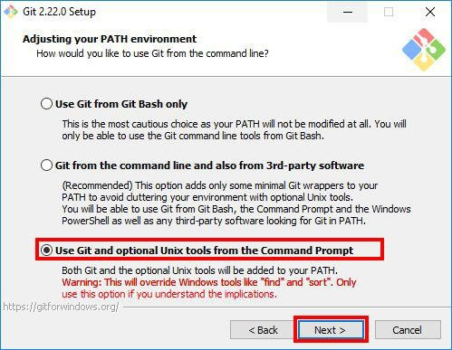

Step 9: Choose HTTPS Transport Backend[Permalink](https://www.stanleyulili.com/git/how-to-install-git-bash-on-windows/#step-9-choose-https-transport-backend)

Next, select “Use the OpenSSL library” and click “Next”.

**39**

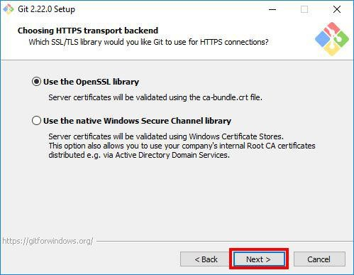

Step 10: Configure the Line Ending Conversions

Select how Git should treat line endings in text files. It’s probably safe to go with the default option “Checkout Windows-Style, commit Unix-style line endings”. Click “Next” to proceed.

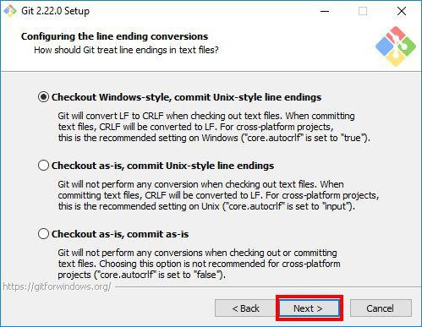

Step 11: Configure the Terminal Emulator to use with Git Bsh[Permalink](https://www.stanleyulili.com/git/how-to-install-git-bash-on-windows/#step-11-configure-the-terminal-emulator-to-use-with-git-bsh)

Next, select the terminal emulator you want Git Bash to use. I will proceed with the default option “Use MinTTY(the default terminal of MSYS2) and click “Next”.

**40**

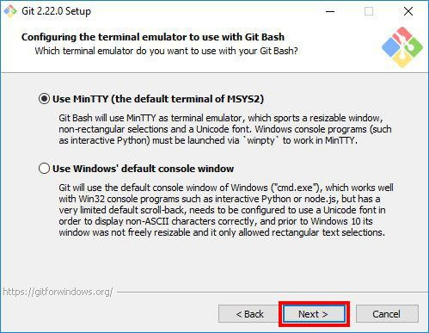

Step 12: Configuring Extra Options

Select the features you want (the default options are fine) and click “Next”.

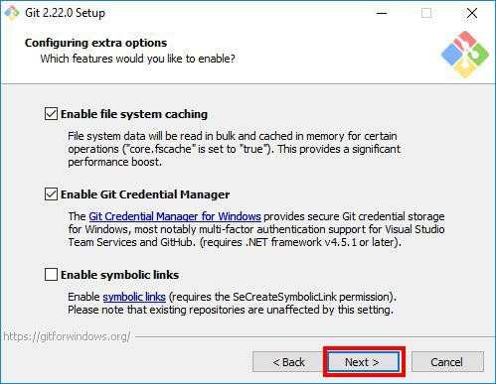

Step 13: Configuring Extra Options

Enable experimental options if you want. Enabling them allows you to try out newer features that are still in development. I don’t enable this, so I will just proceed by clicking “Install” to start the installation process.

**41**

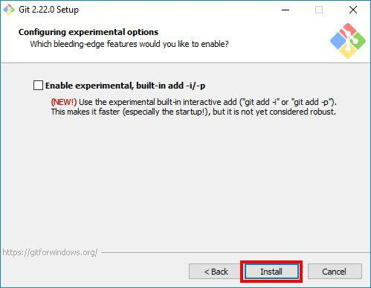

Step 14: Wait for Installation

Now, wait for a few minutes as the Setup Wizard installs Git on your computer.

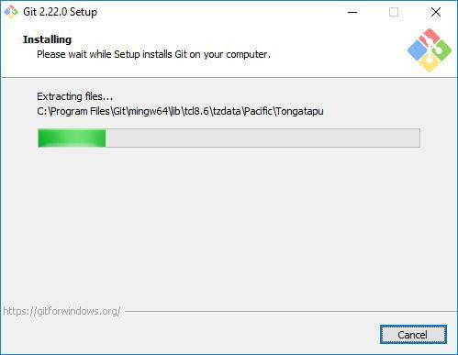

Step 15: Complete the Git Setup Wizard

After the installation has finished, check the “Launch Git Bash” and click “Finish” launching Git Bash.

**42**

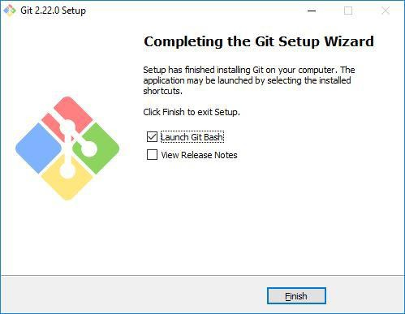

**Git –version**

Run this command in command prompt to know the git version and git is successfully installed or not.

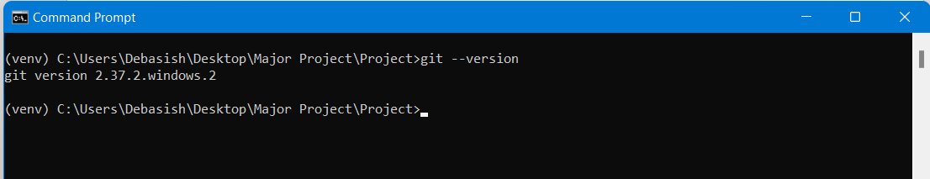

The Git Bash terminal will now open and you will be able to enter Git and Bash commands.

**43**

# CHAPTER-5

## Selected Software or Platform

**What is Visual Studio Code?**

**Visual Studio Code (VS Code)** is a **free, open-source code editor** by Microsoft,

design for efficiency and flexibility in software development. It supports **Windows,**

**Linux, and macOS** and is widely used for **front-end, back-end, and full-stack**

**development**.

**Key Features of VS Code:**

**Fast & Lightweight** – Optimized for quick code editing and debugging.

**Intelligent Code Assistance** – Syntax highlighting, auto-completion, and IntelliSense

for various languages.

**Built-in Debugger** – Simplifies testing and debugging processes.

**Extensive Extensions Marketplace** – Offers plugins for Git, Python, JavaScript, and

more.  
 **Integrated Terminal & Git Support** – Enables seamless version control and

terminal commands.

**Customizable Interface** – Themes, shortcuts, and workspace settings for

personalization.

**Multi-Language Support** – Works well with **HTML, CSS, JavaScript, Python, Java,**

**C++, and frameworks like React, and Node.js**.

**44**

**How to Developed a Project.**

In every Application Development or Project Development basically Follow Three basic step: -

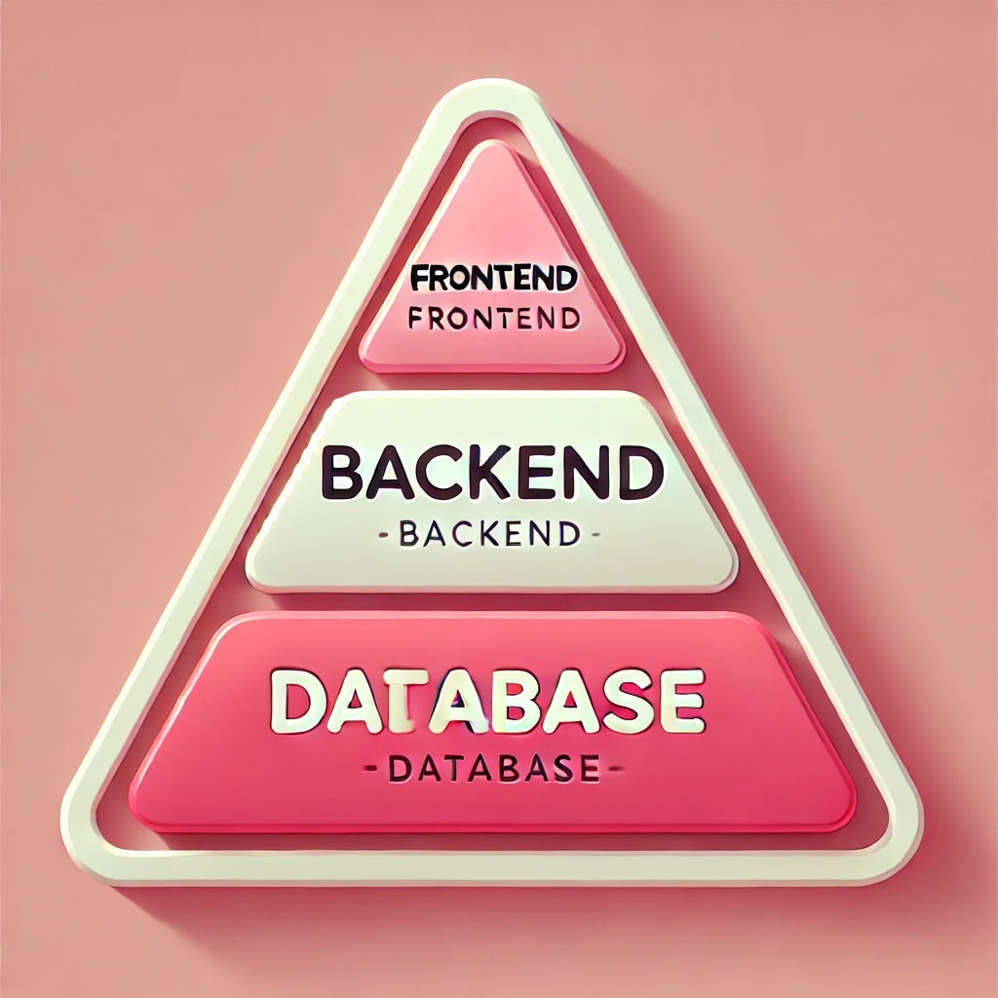

Developing a project requires a **structured approach** to ensure smooth functionality,

scalability, and performance.

A successful project typically follows three key stages:

**1️. Front-End Development – Building the User Interface (UI) and User Experience (UX)**

Front-end development is responsible for the **visual and interactive elements** of a website

or application. It

focuses on creating an intuitive, responsive, and engaging interface that enhances

user experience.

**Key Aspects of Front-End Development:**

**User Interface Design (UI)** – Ensures a visually appealing layout using HTML, CSS, and JavaScript.

**User Experience (UX)** – Enhances interactivity, responsiveness, and accessibility.

**Cross-Browser Compatibility** – Ensures the application works smoothly on all modern browsers.

**Responsive Design** – Uses frameworks like **Bootstrap or Tailwind CSS** to make the website adaptable

across devices.

**Dynamic Interactivity** – Incorporates JavaScript frameworks like **React, Angular, or Vue.js** for better

user engagement.

**2️. Back-End Development – Managing the Core Logic, Authentication, and**

**Server Operations**

Back-end development is the **brain of the application**, handling all the processes behind the scenes.

It is responsible for **data processing, user authentication, security, and server-side logic**.

**Key Aspects of Back-End Development:**

**Business Logic Implementation** – Defines how the application processes data and responds to user actions.

**User Authentication & Authorization** – Manages login systems, user roles, and access control.

**API Development** – Ensures smooth communication between the front-end and back-end using RESTful APIs.

**Error Handling & Security** – Implements encryption, data validation, and security measures to protect user

data.  
 **Scalability & Performance Optimization** – Uses caching techniques, load balancing, and efficient algorithms

for speed.

Common **back-end technologies** include **Spring Boot (Java), Node.js, Django (Python), and Laravel (PHP).**

**3️. Database Management – Handling Data Storage, Retrieval, and Security**

A database is the **foundation of any data-driven application**, storing **user details, product information,**

**transactions, and other critical data**. Database management ensures **efficient data handling, security, and**

**scalability**.

**Key Aspects of Database Management:**

**Data Storage & Organization** – Structures data using relational (SQL) or NoSQL databases.

**Efficient Query Processing** – Optimizes data retrieval using indexing and caching techniques.

**Data Security & Integrity** – Implements encryption, access control, and backup strategies.

**Scalability & Performance Optimization** – Uses database replication and load balancing for handling high

traffic.

**46**

**SPRING BOOT**

**1. Introduction to Spring Boot**

Spring Boot is an open-source **Java-based framework** designed to simplify the development of

**standalone, production-ready Spring applications**. It is built on top of the **Spring Framework** and

eliminates the need for extensive configurations, making it easier to develop enterprise applications, web

services, and microservices.

Unlike traditional Spring applications that require complex XML configurations, Spring Boot follows

a **"convention over configuration"** approach, offering a faster and more streamlined development

process.

**2. Why Use Spring Boot?**

Spring Boot provides several advantages that make it one of the most widely used frameworks for Java

development:

**Auto-Configuration:** Reduces manual configuration, allowing applications to work with minimal setup.

**Embedded Web Servers:** Comes with **built-in Tomcat, Jetty, and Undertow**, eliminating the need for

external web server installations.

**Microservices Ready:** Offers seamless support for developing and deploying **scalable microservices**

**architectures**.

**Spring Boot Starters:** Pre-configured dependencies that simplify project setup (e.g., spring-boot-starter-web,

spring-boot-starter-data-Jpa).

**Actuator for Monitoring:** Provides built-in production monitoring and management capabilities.

**Dependency Management:** Uses **Spring Boot Starter** dependencies to avoid version conflicts.

**Flexible Database Support:** Easily integrates with **MySQL, PostgreSQL, MongoDB, H2, and more**.

**Security Integration:** Supports **Spring Security** for authentication, authorization, and protection against

vulnerabilities.

**3. Key Features of Spring Boot**

**3.1 Spring Boot Starters**

Spring Boot introduces **starter dependencies** that help in **quick project setup**. Instead of manually adding

dependencies, Spring Boot provides predefined starter packs for common functionalities:

**spring-boot-starter-web** → For building RESTful APIs and web applications.

**spring-boot-starter-data-Jpa** → For database interactions using JPA and Hibernate.

**spring-boot-starter-security** → For implementing authentication and authorization.

**spring-boot-starter-validation** → For unit testing using JUnit and Mockito.

**spring-boot-starter-Thymeleaf** → For creating UI templates using Thymeleaf.

**3.2 Auto-Configuration**

Spring Boot automatically detects and configures components based on the dependencies added to the project.

This feature eliminates the need for complex XML or Java-based configuration.

**3.3 Embedded Web Servers**

Spring Boot comes with **embedded web servers** (Tomcat, Jetty, Undertow) that allow applications to run as

standalone services. This removes the need for external application servers like Apache Tomcat.

**3.4 Spring Boot Actuator**

Spring Boot Actuator provides **monitoring and management** features for production environments.

It offers built-in endpoints like:

* /actuator/health → Checks application health status.
* /actuator/info → Provides application metadata.
* /actuator/metrics → Displays performance and usage statistics.

**3.5 Spring Boot CLI (Command-Line Interface)**

Spring Boot CLI allows developers to **write and run Spring Boot applications quickly** using Groovy scripts.

**4.Setting Up a Spring Boot Project**

**4.1 Prerequisites**

Before starting with Spring Boot, ensure the following tools are installed:  
 **Java Development Kit (JDK) 8 or higher**

**Maven or Gradle** for dependency management

**Spring Boot CLI** (optional) for quick project setup

**Integrated Development Environment (IDE)** such as IntelliJ IDEA, Eclipse, or VS Code

**4.2 Creating a Spring Boot Project Using Spring Initializer**

Spring Initializer is an online tool that generates Spring Boot project templates.

**Steps to create a project:**

1. Visit [Spring Initializer](https://start.spring.io/).

2.Select **Project Type**: Maven or Gradle.

3.Choose **Spring Boot Version** (latest stable release).

4.Add **Project Dependencies** (e.g., spring-boot-starter-web, spring-boot-starter-data-jpa).

5.Click **Generate** and download the project.

6.Import the project into your IDE and start coding!

**5. Writing a Basic Spring Boot Application**

**5.1 The Main Class**

Spring Boot applications are bootstrapped with a **main class** that includes the @SpringBootApplication

annotation.java

package com.example.demo;

import org.springframework.boot.SpringApplication;

import org.springframework.boot.autoconfigure.SpringBootApplication;

@SpringBootApplication

public class DemoApplication {

public static void main(String[] args) {

SpringApplication.run(DemoApplication.class, args);

}

}

**6. Creating a Simple REST API in Spring Boot**

Spring Boot simplifies the process of building **RESTful web services**. Here’s how you can create a basic REST API:

**6.1 Creating a Controller**

java

package com.example.demo.controller;

import org.springframework.web.bind.annotation.GetMapping;

import org.springframework.web.bind.annotation.RequestMapping;

import org.springframework.web.bind.annotation.RestController;

@RestController

@RequestMapping("/api")

public class HelloController {

@GetMapping("/hello")

public String sayHello() {

return "Hello, Welcome to Spring Boot!";

}

}

**7. Connecting Spring Boot to a Database**

Spring Boot supports various **databases**, including MySQL, PostgreSQL, and MongoDB.

**7.1 Configure Database in application.properties**

properties

spring.datasource.url=jdbc:mysql://localhost:1211/mydatabase

spring.datasource.username=root

**49**

spring.datasource.password=admin

spring.jpa.hibernate.ddl-auto=update

**7.2 Creating a JPA Entity Class**

java

package com.example.demo.model;

import jakarta.persistence.*;

@Entity

@Table(name = "products")

public class Product {

@Id

@GeneratedValue(strategy = GenerationType.IDENTITY)

private Long id;

private String name;

private double price;

**CHAPTER-6**

## Software Development Life Cycle

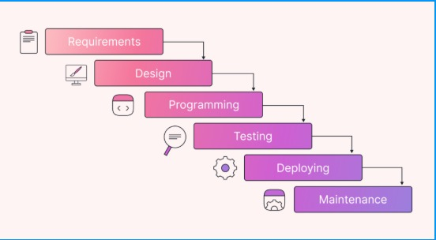

**50**

**1. Introduction**

The **Software Development Life Cycle (SDLC)** is a systematic process used to develop software applications with high quality, efficiency, and cost-effectiveness. It provides a structured approach that helps software teams **plan, design, develop, test, deploy, and maintain software** in a well-organized manner.

SDLC ensures that software is built **on time, within budget, and meets customer requirements** while reducing risks and errors.

**2. Phases of SDLC**

**2.1 Planning Phase**

The **Planning Phase** is the foundation of the SDLC process, where project feasibility is assessed, and a roadmap is created.

**Key Activities:**

* Define project goals, scope, and objectives.
* Conduct **feasibility studies** (technical, operational, and financial).
* Identify potential **risks and mitigation strategies**.
* Allocate budget, resources, and define timelines.

**Deliverables:**

* Project feasibility report.
* High-level project roadmap.
* Risk assessment and mitigation strategies.

**2.2 Requirement Analysis Phase**

The **Requirement Analysis Phase** involves gathering, documenting, and validating software requirements.

**Key Activities:**

* Gather **functional and non-functional requirements** from stakeholders.
* Define **user needs, system inputs/outputs, and performance expectations**.
* Create a **Software Requirement Specification (SRS)** document.
* Review and finalize requirements with stakeholders.

**Deliverables:**

* **SRS Document** (Software Requirement Specification).
* Requirement approval from stakeholders.

**2.3 Design Phase**

The **Design Phase** creates the blueprint of the software, defining its architecture, components, and user interface.

**Key Activities:**

* **High-Level Design (HLD):** Define system architecture, modules, and technology stack.
* **Low-Level Design (LLD):** Detailed design of each module, algorithms, and database schema.
* **UI/UX Design:** Create wireframes, prototypes, and user interface elements.

**Deliverables:**

* System architecture diagram.
* Database schema design.
* UI/UX wireframes and prototypes.

**2.4 Development (Coding) Phase**

The **Development Phase** involves writing the actual code for the application based on design specifications.

**Key Activities:**

* Implement business logic, database integration, and frontend/backend development.
* Follow coding standards, version control, and best practices.
* Perform **unit testing** to validate individual components.
* Use **Git/GitHub** for source code management.

**Deliverables:**

* Source code repository.
* Fully developed software modules.

**2.5 Testing Phase**

The **Testing Phase** ensures the software is **bug-free, functional, and meets requirements**.

**Key Testing Methods:**

* **Unit Testing** – Tests individual components.
* **Integration Testing** – Checks interaction between modules.
* **System Testing** – Validates the complete software functionality.
* **User Acceptance Testing (UAT)** – Ensures the software meets business needs.
* **Performance & Security Testing** – Verifies speed and security compliance.

**Deliverables:**

* Test Plan & Test Cases.
* Bug Reports & Fixes.

**2.6 Deployment Phase**

In the **Deployment Phase**, the software is released for production use.

**Key Activities:**

* Use **deployment strategies** like **rolling deployment** or **blue-green deployment**.
* Deploy the application to **cloud platforms** (AWS, Azure, Google Cloud) or on-premises.
* Conduct **post-deployment monitoring** and bug tracking.

**Deliverables:**

* Live software in production.
* Deployment documentation.

**2.7 Maintenance & Support Phase**

After deployment, the software enters the **Maintenance Phase**, where updates, bug fixes, and optimizations are performed.

**Key Activities:**

* Monitor system performance and logs.
* Fix **bugs, performance issues, and security vulnerabilities**.
* Release software updates and feature enhancements.

**Deliverables:**

* Regular software updates and patches.
* Customer support and issue resolution reports.

**52**

**CHAPTER-7**

**SYSTEM DESIGN**

**Use-case Diagram**

**Use Case** represents the interactions between **users (actors)** and a system (Craft Verse website)

to achieve specific goals. It defines **how different users interact with the system** and what

functionalities the system provides.

• **Customer** – Browses products, adds them to the cart, makes purchases.

• **Admin** – Manages users, products, orders, and website content.

• **Vendor (Artisan)** – Adds and manages craft products, tracks orders.

• **Payment Gateway System** – Handles transactions securely.

• **Delivery System** – Manages shipping and order tracking.

**Data-flow Diagram**

A **Data Flow Diagram (DFD)** is a visual representation of how data flows within a system. It provides a structured overview of how different **users, processes, and external systems** interact with the **Craft Verse** website. The DFD helps in understanding system functionality, optimizing workflows, and ensuring seamless data exchange.

**2. Level 0 DFD (Context Diagram)**

**2.1 Overview**

The Level 0 **(Context Diagram)** provides a high-level representation of the entire Craft Verse system, showing how external entities interact with the system. It does not include internal processing details but focuses on data flow between users and the system.

**2.2 Key Components**

**Actors (External Entities)**

* **Customer**: Browses products, adds items to the cart, places orders, makes payments, and tracks orders.
* **Vendor (Artisan/Seller)**: Adds and manages craft products, tracks orders, and monitors sales.
* **Payment Gateway**: Processes secure transactions.
* **Delivery System**: Handles order shipping and updates tracking details.
* **Customer → Craft Verse System**: Browse products, place orders, make payments, track shipments.
* **Craft Verse System → Payment Gateway**: Processes payments securely.
* **Payment Gateway → Craft Verse System**: Sends payment confirmation.
* **Craft Verse System → Vendor**: Notifies vendors of new orders.
* **Vendor → Craft Verse System**: Updates product listings and processes orders.
* **Craft Verse System → Delivery System**: Sends shipment details for dispatch.
* **Delivery System → Craft Verse System**: Updates delivery status for customers.
* **Admin → Craft Verse System**: Manages system operations, user activities, and generates reports.

**3. Level 1 DFD (Detailed System Breakdown)**

**3.1 Key Subsystems and Data Flow**

**Customer Interactions**

* **User Registration & Login**: Customers create accounts and log in securely.
* **Product Browsing & Search**: Customers explore products based on categories.
* **Shopping Cart & Checkout**: Customers add products to the cart and proceed to payment.
* **Order Tracking**: Customers check their order status post-purchase.
* **Reviews & Ratings**: Customers provide feedback on purchased products.

**Admin Interactions**

* **User Management**: Admin approves, suspends, or removes user accounts.
* **Product Approval & Moderation**: Admin reviews vendor product listings before publishing.
* **Order & Transaction Monitoring**: Admin oversees system transactions and payment settlements.
* **Report Generation**: Admin extracts business performance analytics.

**External System Interactions**

* **Payment Gateway**: Handles transaction authorization and payment verification.
* **Delivery System**: Manages shipping logistics and order tracking updates.

**55**

**CLASS DIAGRAM**

Is a structural diagram in **Unified Modeling Language (UML)** that represents the **blueprint of the Craft Verse system**. It defines the **classes, attributes, methods, and relationships** between various entities in the system.

The **Craft Verse** website is an **e-commerce platform** where customers can browse and purchase craft products, vendors can manage their listings, and administrators oversee system operations. This class diagram provides a **detailed object-oriented view** of the system.

**2. Key Components of the Class Diagram**

**2.1 Major Classes & Their Responsibilities**

**1️⃣ Customer Class**

**Attributes:**

* customerID: Unique identifier for each customer.
* name: Customer’s full name.
* email: Contact email.
* password: Encrypted password.
* address: Shipping address.
* orderHistory: List of past orders.

**Methods:**

* register(): Creates a new customer account.
* login(): Authenticates customer credentials.
* placeOrder(): Processes order checkout.
* trackOrder(): Retrieves order status.
* writeReview(): Allows customers to rate and review products.

**3️⃣ Product Class**

**Attributes:**

* productID: Unique identifier for each product.
* productName: Name of the craft item.
* description: Brief product details.
* price: Cost of the product.
* stockQuantity: Available stock count.
* category: Type of craft item.
* vendorID: The seller who owns the product.

**Methods:**

* updateStock(): Adjusts stock levels after a sale.
* applyDiscount(): Sets promotional discounts.

**4️⃣ Order Class**

**Attributes:**

* orderID: Unique order identifier.
* customerID: ID of the customer placing the order.
* productList: Items purchased in the order.
* totalAmount: Total payment for the order.
* orderStatus: Current order stage (Pending, Shipped, Delivered).
* paymentStatus: Paid/Unpaid status.
* shippingAddress: Delivery location.

**Methods:**

* processOrder(): Confirms order placement.
* cancelOrder(): Cancels an order if applicable.
* updateStatus(): Updates shipping progress.

**5️⃣ Payment Class**

**Attributes:**

* paymentID: Unique transaction identifier.
* orderID: Associated order number.
* customerID: Paying customer’s ID.
* amount: Total amount paid.
* paymentMethod: Mode of payment (Credit Card, PayPal, UPI).
* paymentStatus: Confirmation of successful payment.

**Methods:**

* processPayment(): Handles transaction requests.
* validatePayment(): Ensures payment security.

**6️⃣ Admin Class**

**Attributes:**

* adminID: Unique identifier for administrators.
* username: Login credentials.
* email: Contact details.

**Methods:**

* manageUsers(): Adds, removes, or updates customers and vendors.
* approveProducts(): Moderates product listings.
* generateReports(): Creates business performance analytics.

**57**

**System Architecture Design**

A **1. Introduction**

The **System Architecture Design** defines the overall structure of the **Craft Verse** platform, including its **components, data flow, and interactions between different system layers**. This architecture ensures the platform is **scalable, efficient, and secure** for both customers and vendors.

Craft Verse follows a **three-tier architecture**, consisting of:

1. **Presentation Layer** (Frontend) – Handles user interactions.
2. **Business Logic Layer** (Backend) – Processes requests and manages business rules.
3. **Data Layer** (Database) – Stores and retrieves data efficiently.

**2. System Components & Layers**

**2.1 Presentation Layer (Frontend)**

* Technologies: **HTML, CSS, JavaScript, React.js**
* Responsibilities:  
   Provides an intuitive user interface for customers, vendors, and admins.  
   Manages product browsing, cart operations, order tracking, and profile management.  
   Sends user requests to the backend via REST APIs.

**2.2 Business Logic Layer (Backend)**

* Technologies: **Spring Boot (Java), REST APIs**
* Responsibilities:  
   Handles authentication & authorization (user login, role-based access).  
   Processes product listings, order management, and payments.  
   Implements business rules for discounts, stock updates, and notifications.

**2.3 Data Layer (Database Management)**

* Technologies: **MySQL (Relational Database)**
* Responsibilities:  
   Stores customer, vendor, product, order, and payment data.  
   Ensures **data integrity and security** using encryption & backup mechanisms.  
   Manages transactional consistency for orders and payments.

**2.4 External Services & APIs**

1. **Payment Gateway (Razorpay, PayPal, Stripe)** – Handles secure transactions.
2. **Shipping & Delivery System** – Updates order tracking & delivery status.
3. .

**58**

Class Diagram

In software engineering, a class diagram in the Unified Modeming Language is a type of static structure diagram that describes the structure of a system by showing the system’s classes, their attributes, operations, and the relationships among objects.

**59**

**CHAPTER-8**

**METHODOLOGY**

**1. Introduction**

The **Craft Verse** project follows a structured **Software Development Life Cycle (SDLC)** approach combined with **Agile Methodology** to ensure efficient execution, continuous improvements, and flexibility in development. This methodology helps in delivering a **scalable, secure, and user-friendly e-commerce platform** where customers can purchase craft items, vendors can manage their products, and administrators can oversee system operations.

The Agile approach allows for **incremental development**, ensuring adaptability to changing requirements and quicker releases.

**2. Development Approach**

The **Agile Methodology** has been chosen for the development of Craft Verse due to its **iterative nature, frequent feedback cycles, and focus on customer satisfaction**.

**2.1 Key Features of Agile Methodology**

* **Incremental Development** – Features are developed and delivered in multiple iterations.
* **User-Centric Approach** – Regular feedback from customers, vendors, and admins ensures system improvements.
* **Continuous Testing & Bug Fixing** – Reduces defects and enhances system reliability.
* **Flexibility in Requirements** – Allows modifications based on market trends and stakeholder needs.

**3. Methodology Phases**

**3.1 Requirement Gathering & Analysis**

In this phase, the project team collaborates with stakeholders to define **functional and non-functional requirements**.

Identifying system requirements from customers, vendors, and administrators.  
 Conducting market research to understand user expectations.  
Documenting requirements in the **Software Requirement Specification (SRS)**.

**3.2 System Design**

The system is designed to provide a **scalable and efficient architecture** using **three-tier architecture (Frontend, Backend, and Database)**.

**Database Design:** Structuring tables for customers, vendors, products, orders, and payments.  
 **System Architecture Design:** Defining the interactions between different system layers.  
**Wireframing & UI/UX Design:** Creating a responsive and intuitive user interface.

**3.3 Development Phase**

This phase involves **coding and implementation** of the planned design using **Spring Boot (Backend) and React.js (Frontend)**.

**Frontend Development:** Developing interactive UI components using **React.js, HTML, CSS, and JavaScript**.  
 **Backend Development:** Implementing business logic, authentication, and APIs using **Spring Boot**.  
**Database Integration:** Storing and retrieving data efficiently using **MySQL**.  
**Security Implementation:** Applying **JWT authentication and role-based access control**.

**3.4 Testing Phase**

The testing phase ensures that the platform functions correctly, is **secure**, and meets **user expectations**.

**Unit Testing:** Verifying individual components and functions.

**Integration Testing:** Ensuring seamless interaction between system modules.  
 **User Acceptance Testing (UAT):** Gathering feedback from stakeholders and making improvements.

**3.5 Deployment Phase**

Once testing is complete, the application is deployed for **public access**.

Hosting the application on **cloud platforms (AWS, Google Cloud, Azure)** for scalability.  
Integrating **third-party payment gateways (Razorpay, PayPal, Stripe)** for secure transactions.  
Enabling **real-time order tracking** via third-party logistics APIs.

**3.6 Maintenance & Support**

Post-deployment, regular monitoring and updates are performed to ensure optimal performance and security.

Continuous **monitoring of system performance** and fixing security vulnerabilities.  
Enhancing **features** based on user feedback.

**62**

# CHAPTER-9

CODING

**Landing page**

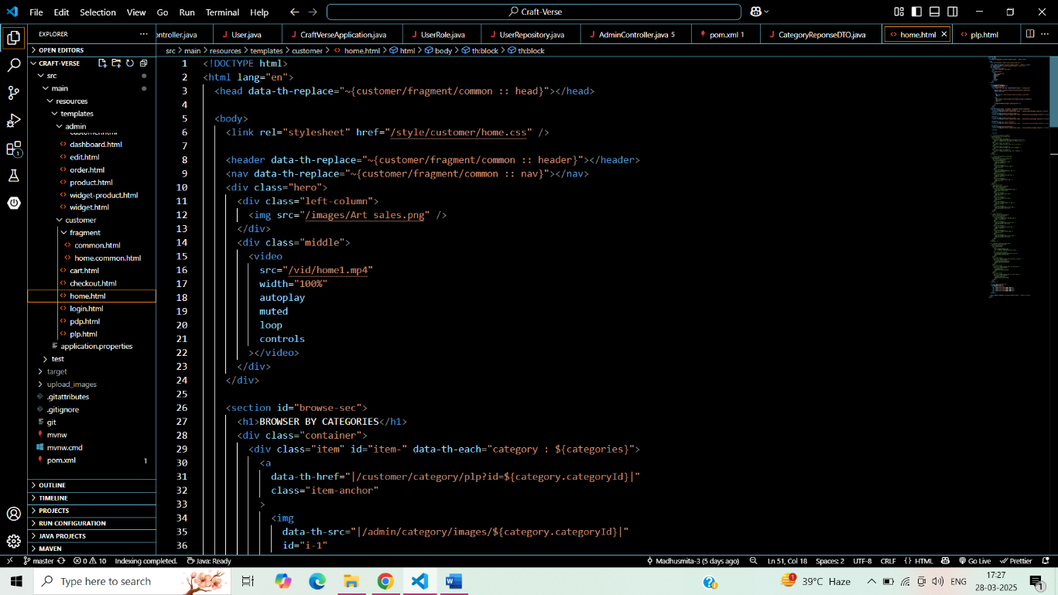

**63**

**Product Listing Page (PLP)**

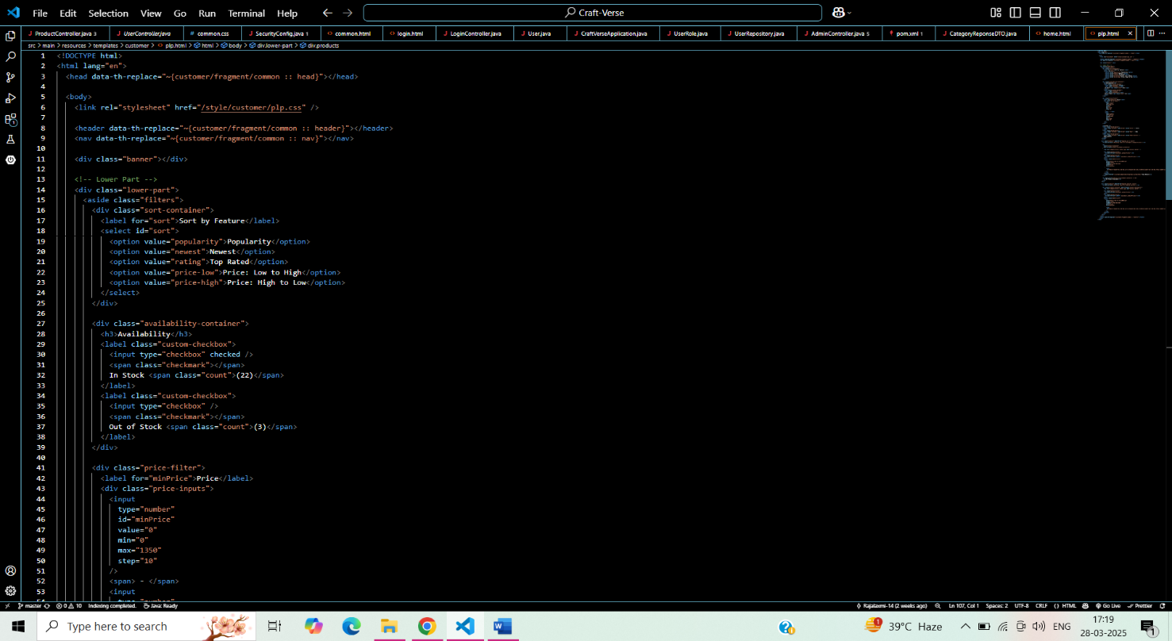

**Product Detail Page**

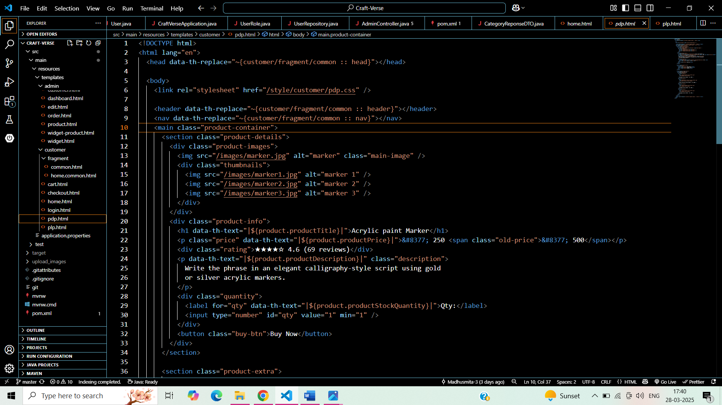

**64**

**Application Properties**

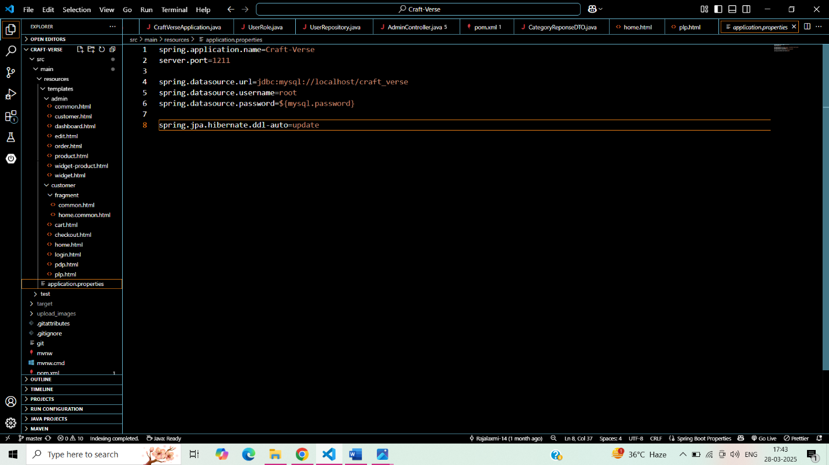

**65**

**Craft-Verse Application**

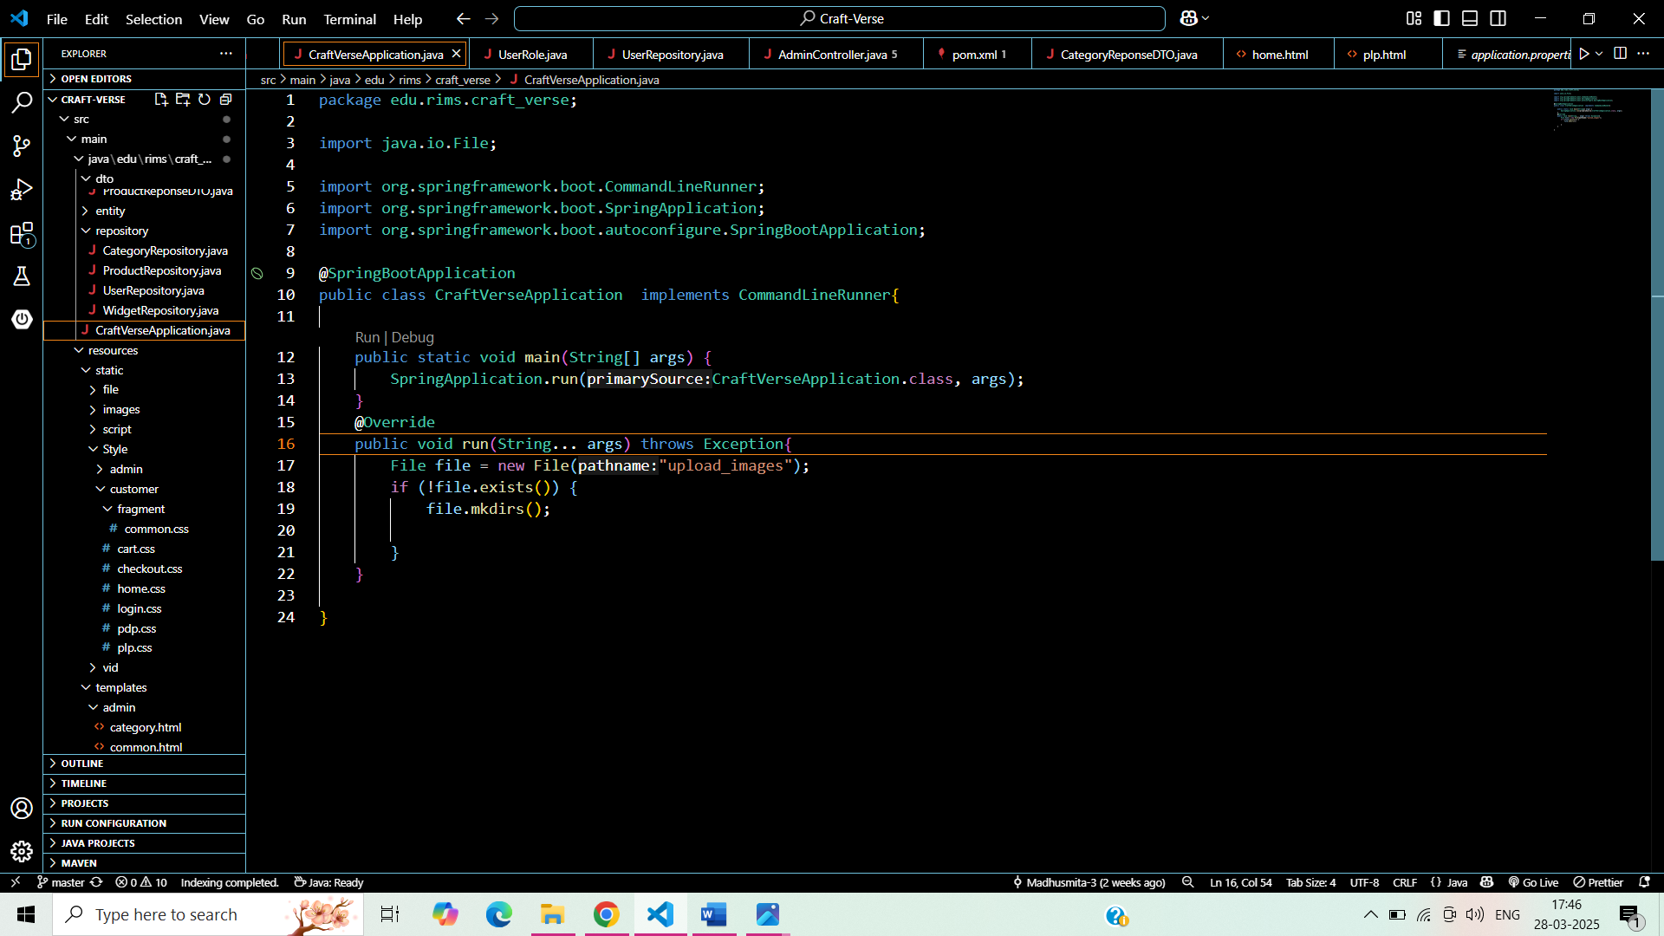

1.***Repository***

* 1. Category Repository

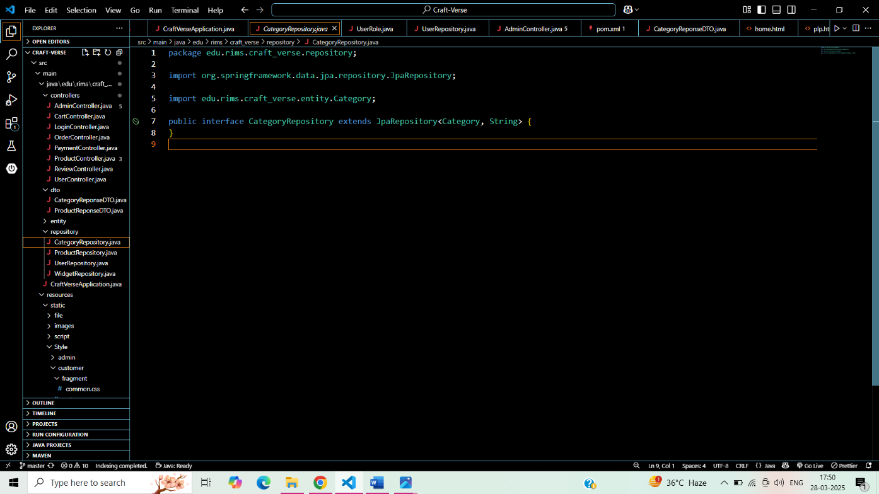

1.2Product Repository

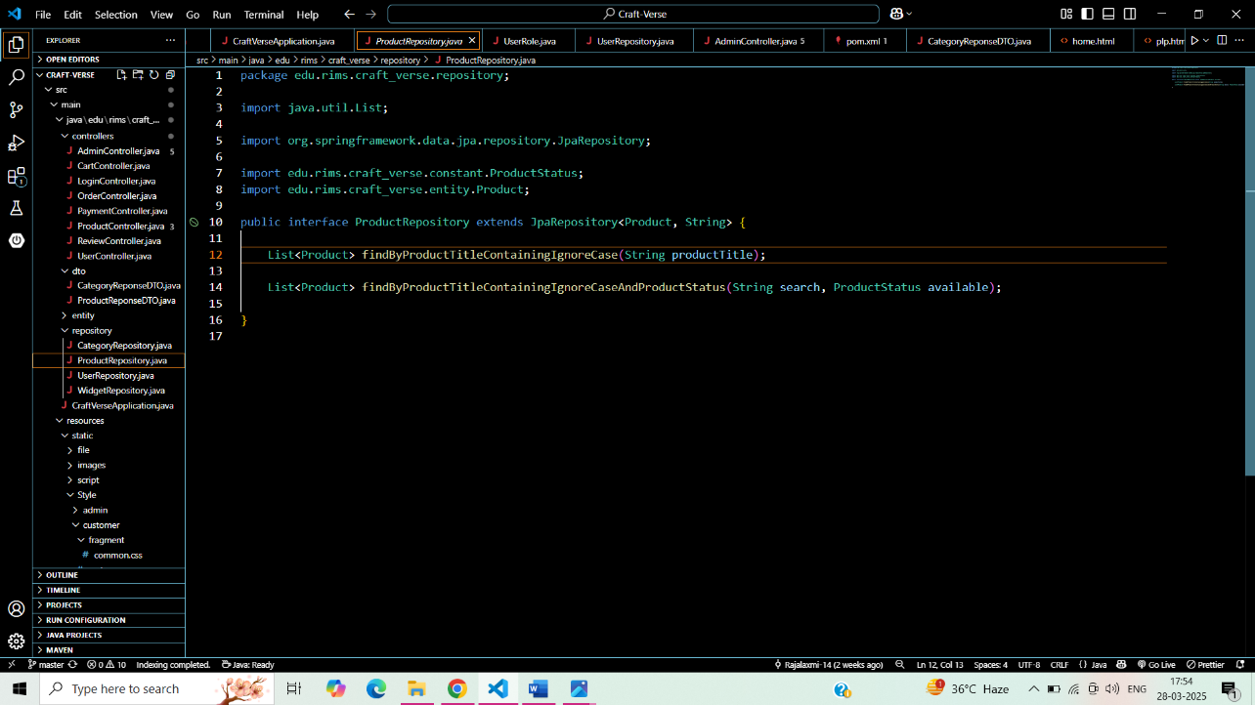

1.3 User Repository

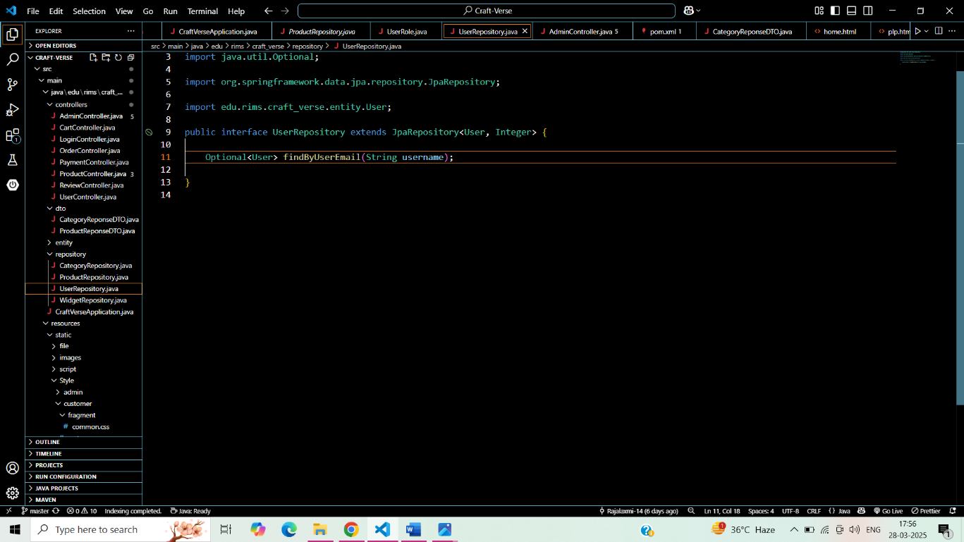

1.4 Widget Repository

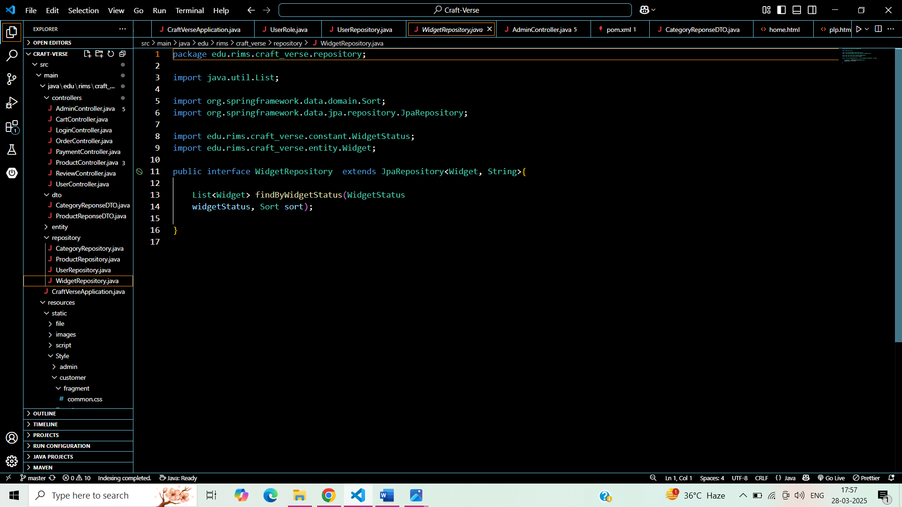

2. Controller

2.1 Product controller

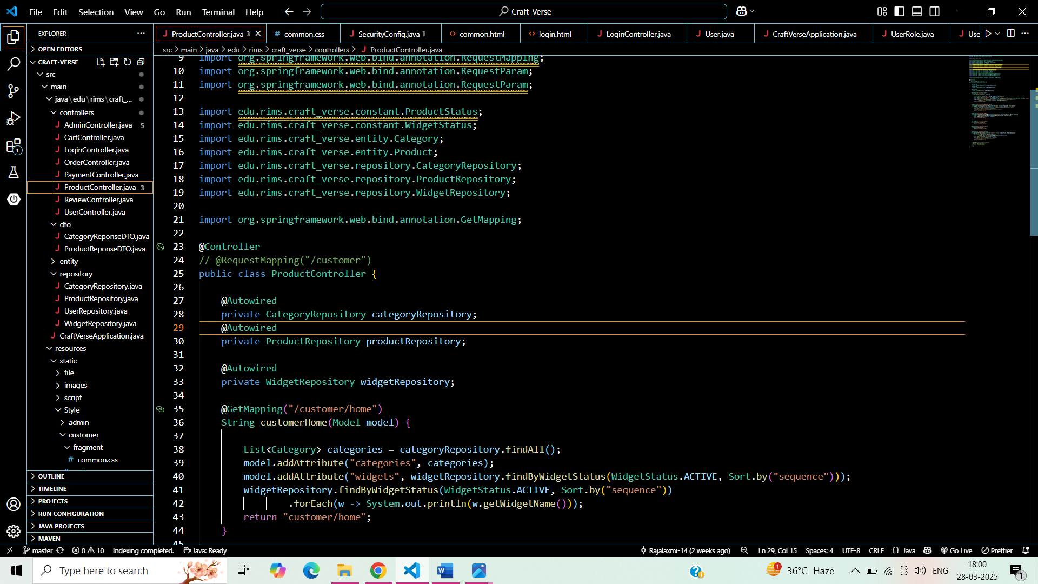

2.2 Admin Controller

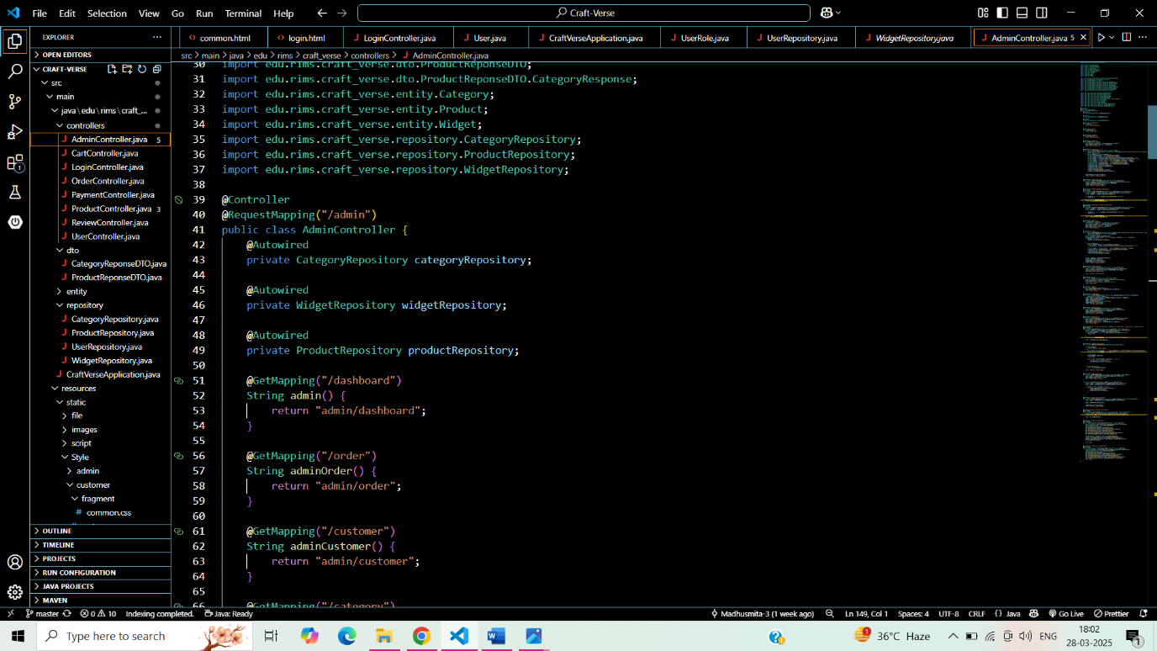

2.3 Login Controller

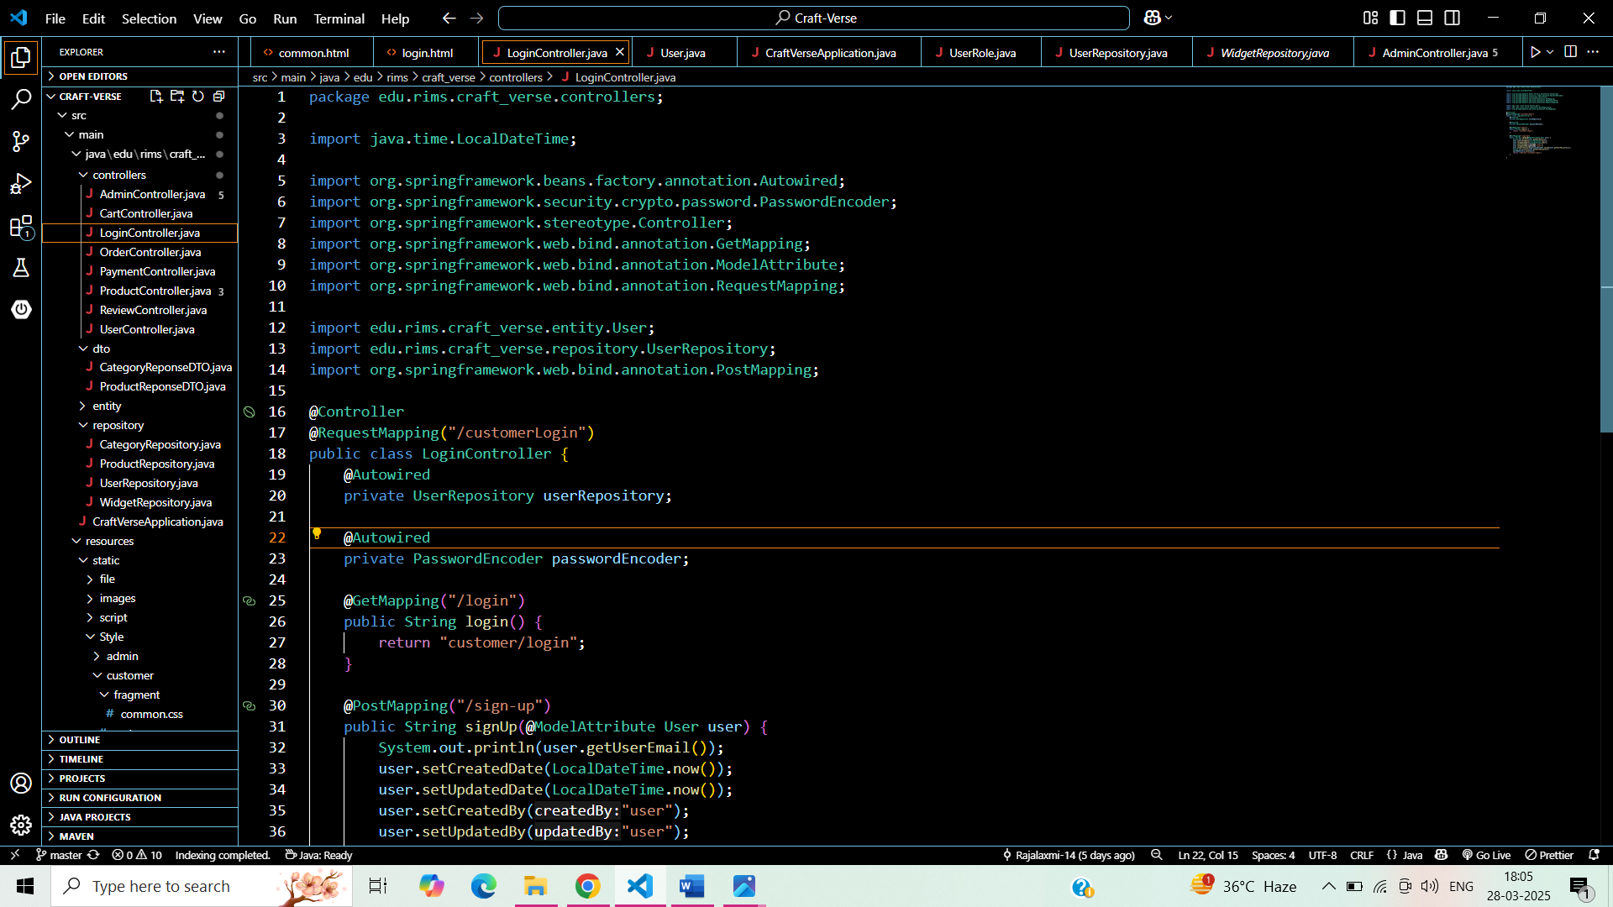

2.4 Cart Controller

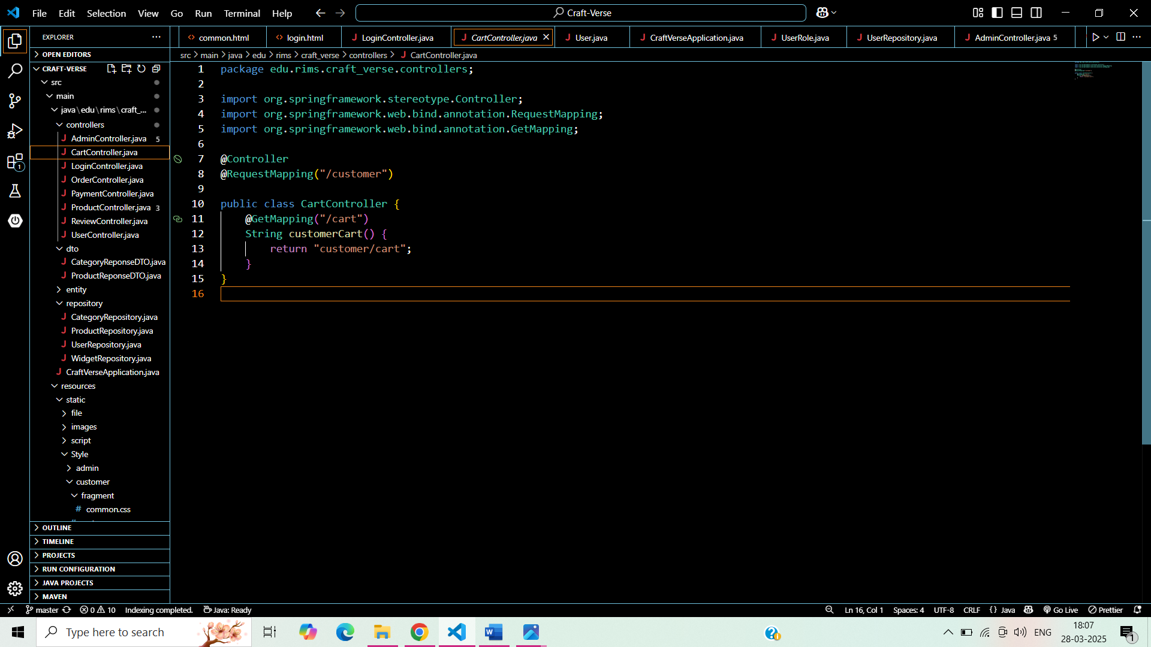

1. Spring Security

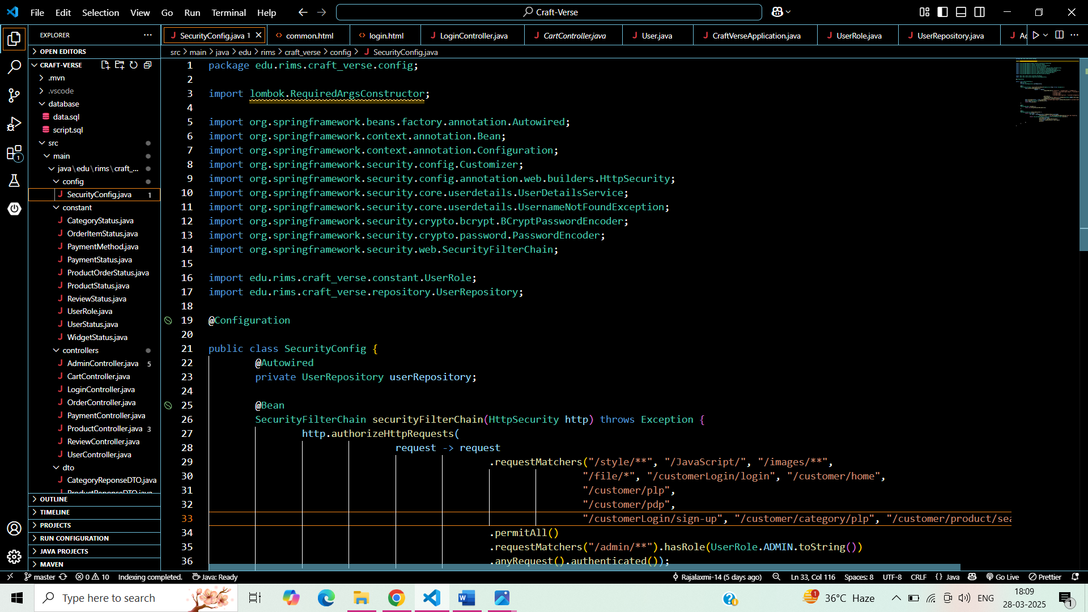

4.Database

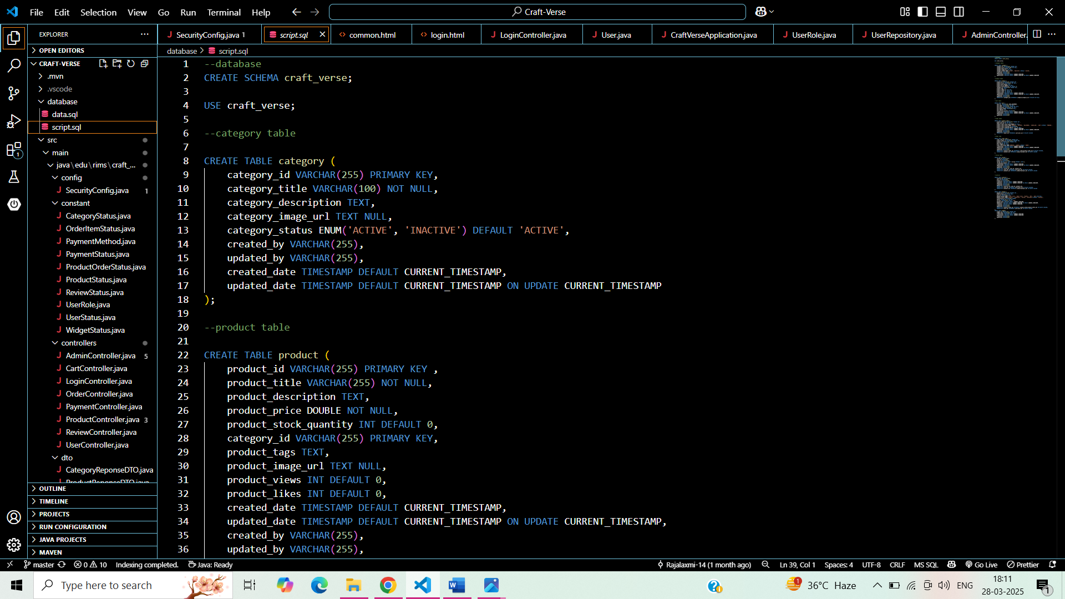

**72**

## Snapshot

**Homepage**

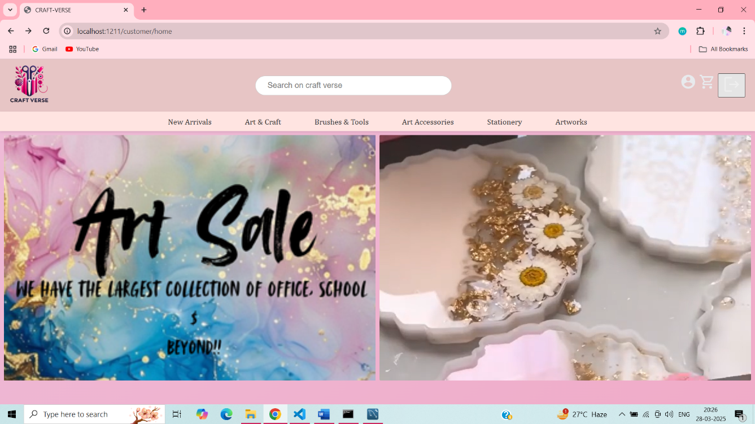

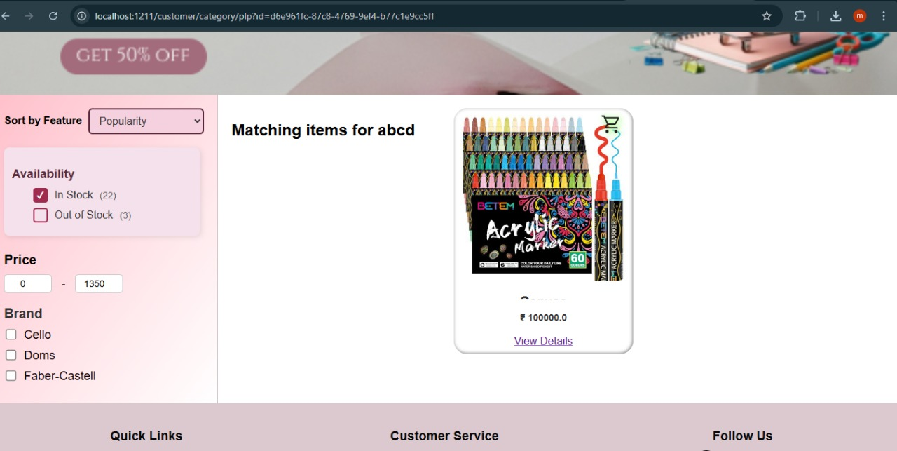

**73**

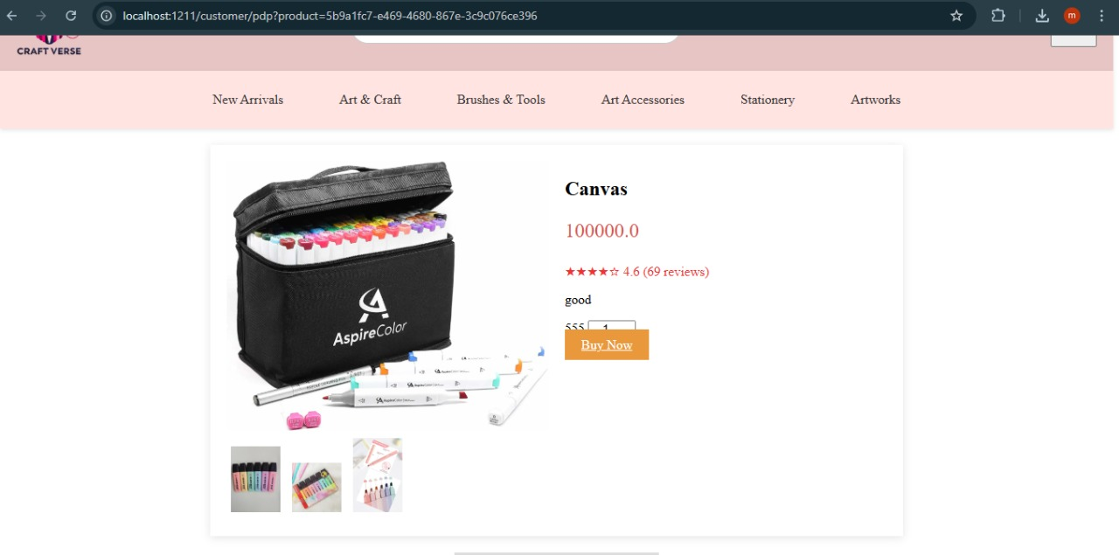

LOGIN/SIGN-IN PAGE

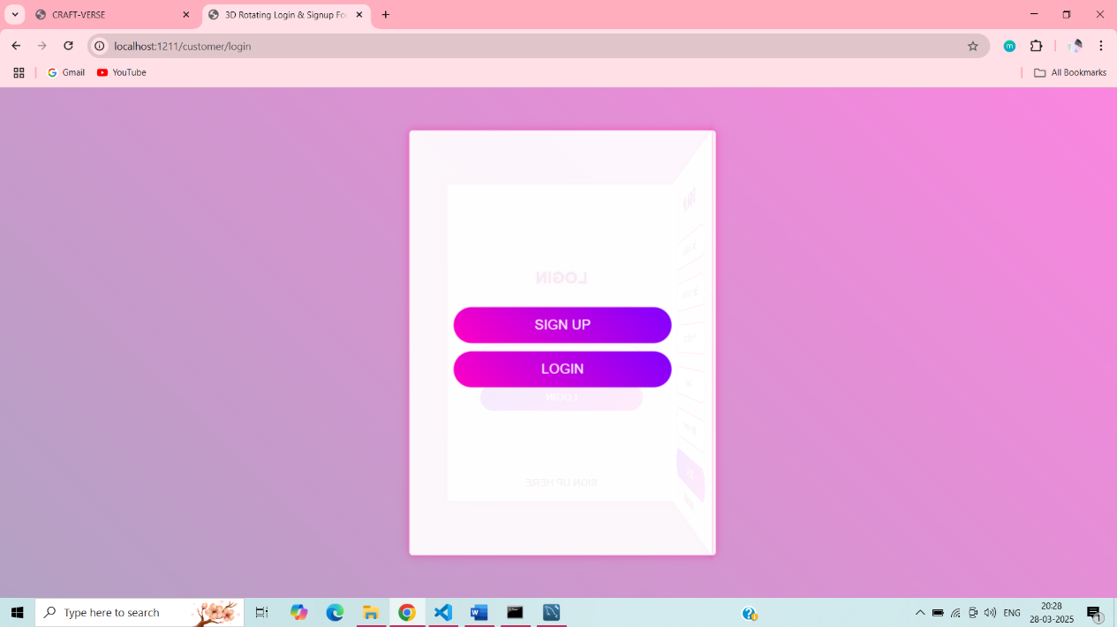

**74**

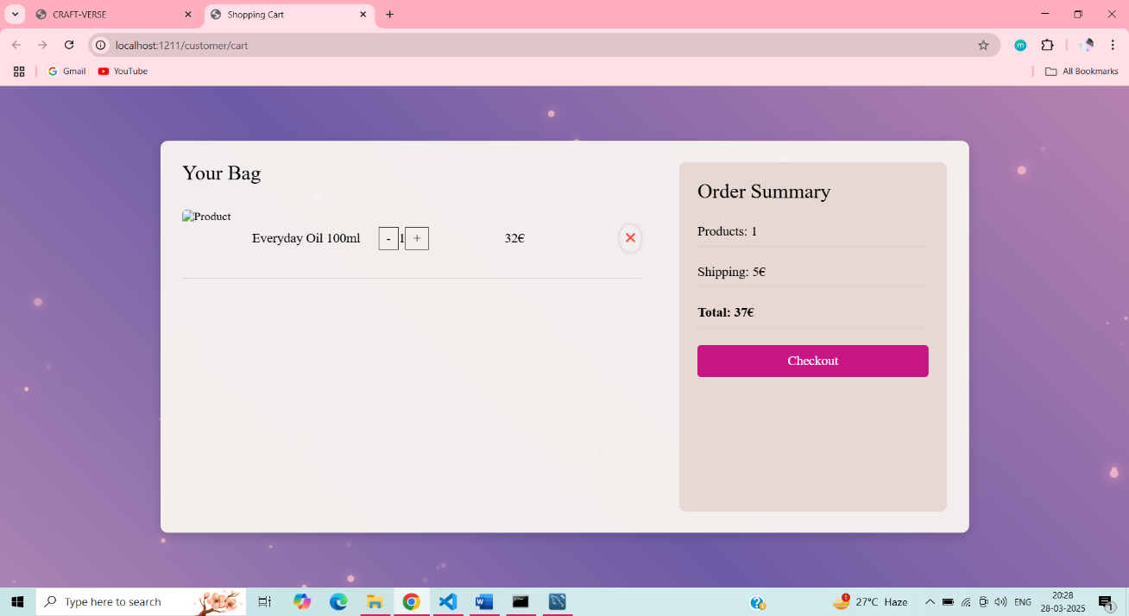

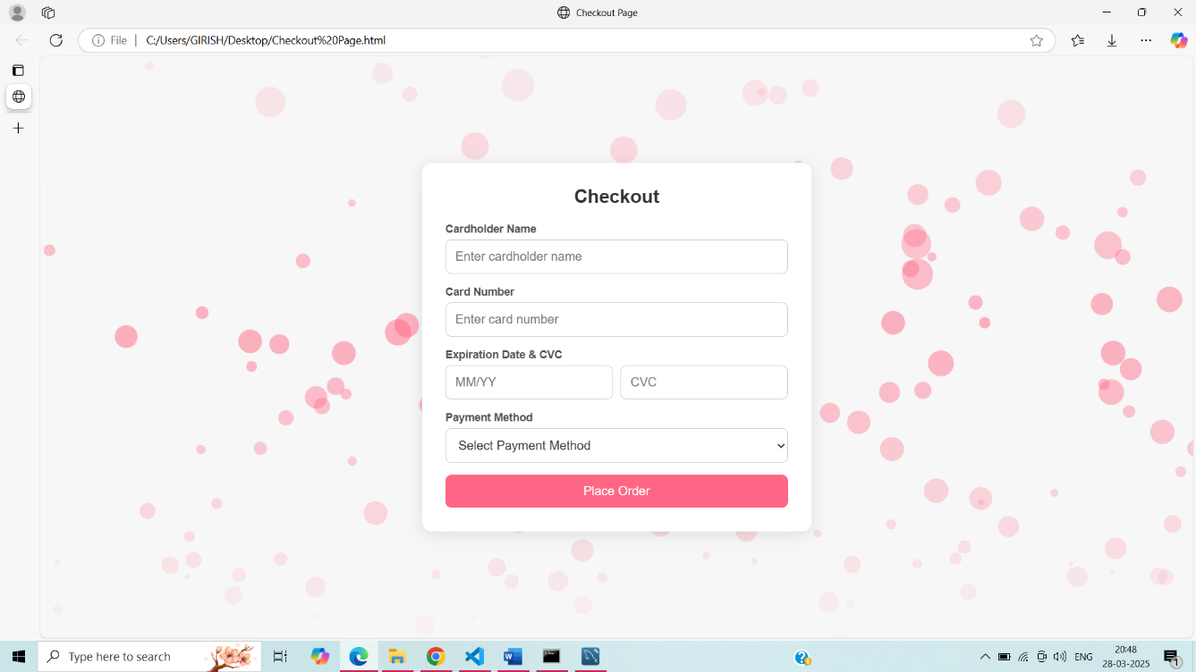

**75**

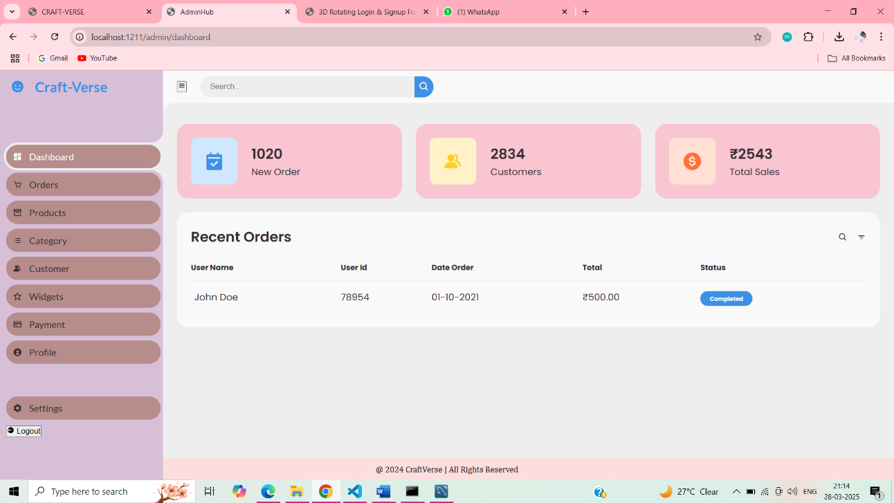

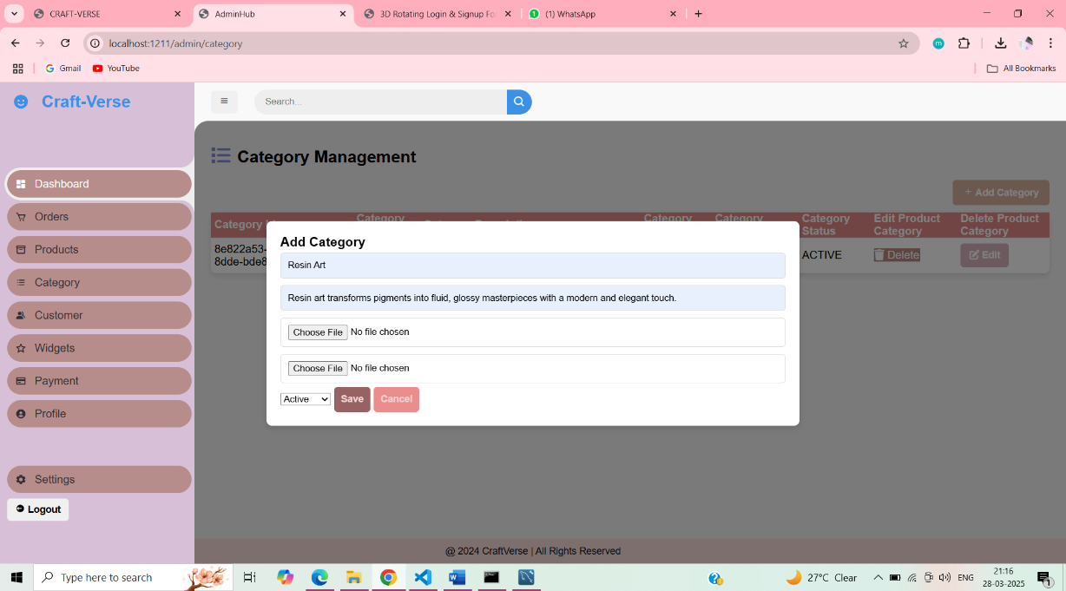

# CHAPTER-10

### Testing

Testing is a critical phase in the **Craft Verse** development process, ensuring that the **e-commerce platform functions smoothly, remains secure, and provides a seamless user experience**. The platform must be tested for **usability, security, performance, and compatibility** to meet the expectations of **customers, vendors, and administrators**.

This document outlines the **types of testing implemented in Craft Verse**, covering **functional, non-functional, and security aspects**.

**2. Testing Phases Implemented for Craft Verse**

**2.1 Functional Testing (Ensuring Core Features Work Properly)**

**Key Areas Tested: -**

**User Registration & Login** – Ensures customers and vendors can securely register and log in.  
 **Product Listing & Search** – Tests if vendors can upload products and if customers can search/filter items correctly.  
 **Shopping Cart & Checkout** – Verifies adding/removing items, updating quantities, and placing orders.  
 **Payment Processing** – Ensures transactions via Razorpay, PayPal, or Stripe are processed securely.  
 **Order Tracking & Notifications** – Tests order status updates, vendor processing, and delivery tracking.  
 **Review & Rating System** – Validates user feedback and spam protection measures.

**2.2 Usability Testing (Ensuring a User-Friendly Experience)**

This testing focuses on how **intuitive and accessible** the website is for customers and vendors.

**Key Areas Tested:**

**UI/UX Responsiveness** – Checks navigation, ease of use, and page load speed.  
**Customer Journey Testing** – Simulates a typical user's interaction with the platform (browsing, adding items to the cart, purchasing, and tracking orders).

**2.3 Compatibility Testing (Cross-Browser & Device Testing)**

Ensures the website works correctly across **different browsers and operating systems**.

**Key Areas Tested:**

**Multi-Browser Support** – Chrome, Firefox, Safari, Edge.  
 **Device Compatibility** – Windows, macOS, iOS, and Android.  
 **Responsive Design Testing** – Ensures images, buttons, and text scale correctly on different screens.

**2.4 Performance Testing (Ensuring Speed & Scalability)**

This testing ensures **Craft Verse can handle high traffic and large product listings** without slowing down.

**Key Areas Tested:**

**Load Testing** – Tests how the platform performs with multiple concurrent users.   
 **Database Optimization** – Ensures MySQL queries are optimized for fast transactions.

**2.5 Security Testing (Protecting User Data & Transactions)**

Security testing ensures that **customer and vendor data is protected**, and the payment system is secure from fraud.

**Key Areas Tested:**

**User Authentication & Role-Based Access Control** – Ensures only authorized users can access sensitive information.  
 **Data Encryption** – Validates that user passwords and payment details are encrypted.  
 **SQL Injection & XSS Protection** – Tests for vulnerabilities against hacking attacks.  
 **Secure Payment Processing** – Ensures third-party payment integration follows PCI-DSS compliance.

**2.6 Database Testing (Ensuring Data Integrity & Efficiency)**

Database testing ensures **data consistency, retrieval speed, and error handling**.

**Key Areas Tested:**

**Data Consistency** – Ensures product stock updates correctly after purchases.  
 **Backup & Recovery** – Tests data restoration in case of system failures.  
**Query Performance** – Ensures fast response times for product searches and transactions.

**2.7 Payment Gateway Testing (Ensuring Secure Transactions)**

Since Craft Verse integrates **multiple payment gateways**, this testing ensures **error-free transactions**.

**Key Areas Tested:**

**Successful Transactions** – Ensures payments go through correctly.  
 **Failed Payment Handling** – Checks how the system reacts to declined transactions.  
 **Refund & Cancellation Process** – Verifies refund requests are processed correctly.

# 

# CHAPTER-11

### Conclusion and Future Scope

**1. Conclusion**

The **Craft Verse** platform has been successfully developed as an **e-commerce solution** catering to artisans and craft vendors, providing them with a **user-friendly, scalable, and secure online marketplace**. The project effectively meets its objective of enabling customers to explore and purchase unique handmade products while ensuring vendors have a streamlined process for listing and managing their crafts.

Through the implementation of **Spring Boot for backend development, React.js for frontend UI, and MySQL for database management**, the platform ensures:

* **Seamless user experience** with an intuitive and interactive interface.
* **Robust security** through role-based access control and secure payment gateways.
* **Scalability and performance optimization** using cloud-based deployment.
* **Efficient order processing** and real-time order tracking for customers.
* **Vendor management system** allowing artisans to list and sell products effortlessly.

Additionally, **comprehensive testing strategies** including **functional, usability, performance, and security testing** have ensured the platform is **reliable, bug-free, and optimized for smooth operations**.

In conclusion, **Craft Verse successfully bridges the gap between artisans and craft buyers, creating a sustainable marketplace that promotes traditional and contemporary handmade crafts**.

**2. Future Scope**

As technology and customer expectations evolve, Craft Verse has immense potential for **future enhancements** to expand its functionalities, improve performance, and grow into a globally recognized craft-selling platform.

**2.1 Feature Enhancements**

**AI-Powered Craft Recommendations** – Implementing **machine learning algorithms** to provide personalized product recommendations based on user preferences.  
**Augmented Reality (AR) Product Visualization** – Allowing customers to **preview craft items in their home environment** before making a purchase.  
 **Live Bidding System for Exclusive Handmade Products** – Introducing an **auction-style selling model** where users can place bids on unique craft items.  
 **Social Media Integration** – Enabling direct sales via **Facebook, Instagram, and Pinterest** to increase vendor reach and sales.

* 1. **Performance & Scalability Improvements**

**Adoption of Microservices Architecture** – Transitioning from a monolithic system to **microservices** to enhance **scalability and flexibility**.

**Serverless Computing for Cost Optimization** – Utilizing **AWS Lambda, Google Cloud Functions** to optimize **cost and performance**.

**Implementation of Caching Mechanisms** – Using **Redis/Memcached** for **faster product retrieval and improved search performance**.

**81**

# CHAPTER-12

## References

1. ***Spring Boot Documentation*** *– Official guide for backend development and REST API implementation.  
   🔗* [*https://spring.io/projects/spring-boot*](https://spring.io/projects/spring-boot)
2. ***Java SE Documentation*** *– Core Java programming reference for backend development.  
   🔗* [*https://docs.oracle.com/javase/*](https://docs.oracle.com/javase/)
3. ***MySQL Documentation*** *– Database management and structured query language (SQL) reference.  
   🔗* [*https://dev.mysql.com/doc/*](https://dev.mysql.com/doc/)
4. ***Thymeleaf Documentation*** *– Template engine used for dynamic UI rendering in Spring Boot applications.  
   🔗 https://www.thymeleaf.org/documentation.html*

*5.* ***MDN Web Docs*** *– HTML, CSS, and JavaScript references for frontend development.  
 🔗* [*https://developer.mozilla.org/en-US/*](https://developer.mozilla.org/en-US/)

*6.* ***GeeksforGeeks*** *– Guides on Java, Spring Boot, and MySQL integration.  
 🔗* [*https://www.geeksforgeeks.org/*](https://www.geeksforgeeks.org/)

*7.* ***GitHub Documentation*** *– Version control and repository management for the Craft Verse project.  
 🔗* [*https://docs.github.com/en*](https://docs.github.com/en)

**82**